StudyDesk

A Guide for Students



Table of Contents
Overview 4
Section I StudyDesk 5
How to Register 5
Open Class 10
Back to Key Concept Last Visited 12
Learning Tools 13
How to Study 19
Section II Learning Center 20
Go to Course 20
Set Daily Quiz Chapters 20
View Assignment 22
Objective 23
Subjective 24
Thought Type 29
Section III Test Center 32
Practice Session 32
View Section Tests 35
View Diagnostic Test 35
Daily Quiz 36
Weekly Assignment 36
Test Center Strategy 37
Section IV Other Tools 38
Take Notes 38
My Notes 39
My Questions 39
Private Messages 39
Friend in Need 40
My Hotlinks 41
Section V Reports 42
My Rank 42
Practice Session Reports 44
Time Spent 45
Section VI How to Study 46
Study Tips 46
Find a quiet place 46
Practice good time management 46
Organization 46
Tell your family and friends about continuing your education 46
Study Techniques 47
Take advantage of practice tests 47
Use mentors 47
Review all test answers 47
Find a study buddy 47

Overview

StudyDesk is an interactive learning tool which was created to assist students with the online learning process. For each registered class, the student will have access to the StudyDesk in order to track his/her learning. The StudyDesk provides many unique features to help guide students through the course. This manual is broken down into six sections that will describe each feature and its functions. Let us begin by listing each section.
Section I – StudyDesk
- How to register
- Provides valuable features and resources to students
Section II – Learning Center
- Provides learning resources to students
Section III – Test Center
- Provides testing resources to students
Section IV – Other Tools
- Provides communication tools to students
Section V – Reports
- Provides various reports to track student progress
Section VI – How to Study
- Provides study tips to help student succeed

Section I StudyDesk
The StudyDesk contains many invaluable features for students. In this section, we will explain how to register for StudyDesk and how to use the icons featured on the StudyDesk main page. To begin, we will address how to register, the StudyDesk’s main page and its features.

How to Register
Registering for StudyDesk is easy. To begin the registration process, click on the Sign Up button on the right (see Figure 1). Once you have clicked the sign up button, you will be taken to the registration page. Here you can either register as a Mentor or as a Student (see Figure 2).
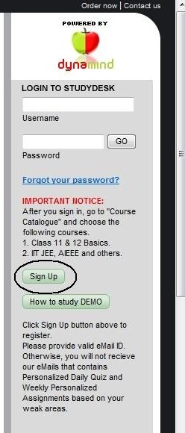
Figure 1: Sign Up

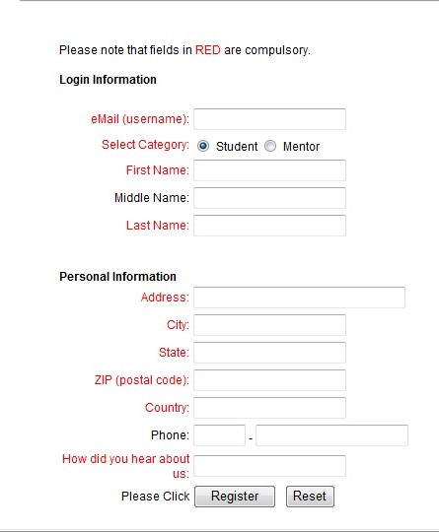
Figure 2: Registration
Once you have successfully registered, you will receive your temporary password via email (see Figures 3 and 4). Once you have received your temporary password you will be able to log in. After logging in with your username and password, you will be asked to change your password (see Figure 5). Once you have successfully changed your password, you will be taken to the course catalog (see Figure 7). You will be able to choose the classes you wish to take. If you decide you want to have full course access, you must purchase a key.
This page contains a moveable menu on the left. This menu moves as you scroll through the page so it is always visible; see Figure 9. You will also see a header with other options.
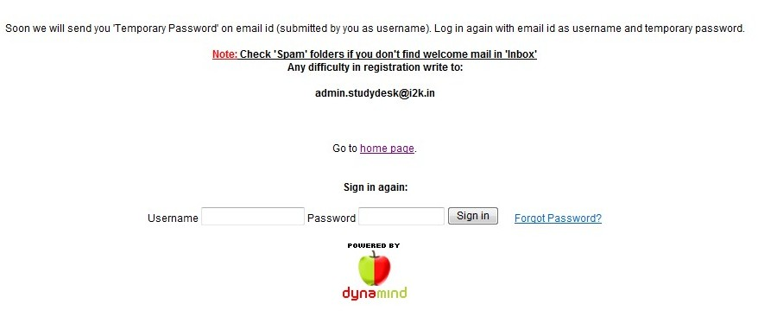
Figure 3: Successful Registration
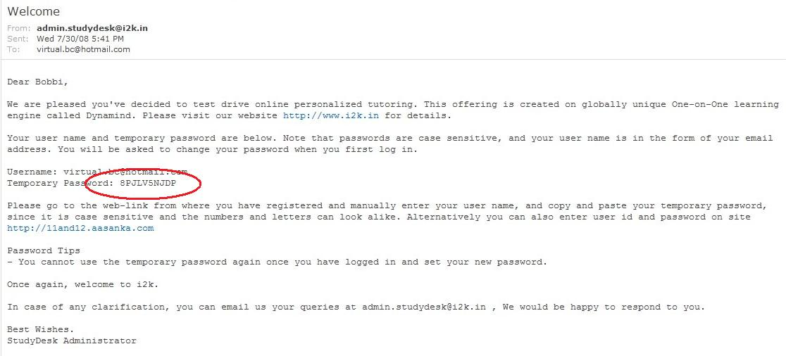
Figure 4: Temporary Password Email
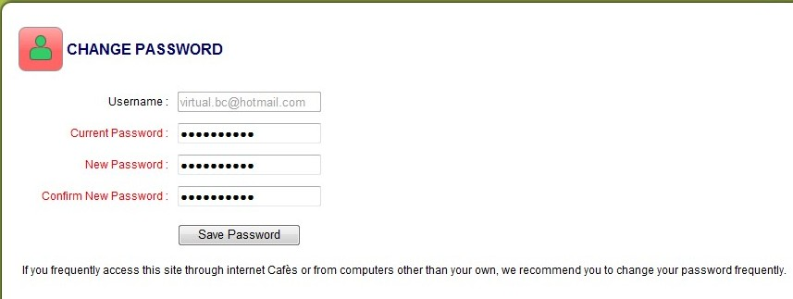
Figure 5: Change Password
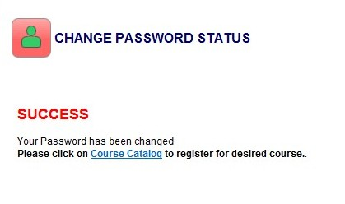
Figure 6: Successful Password Change
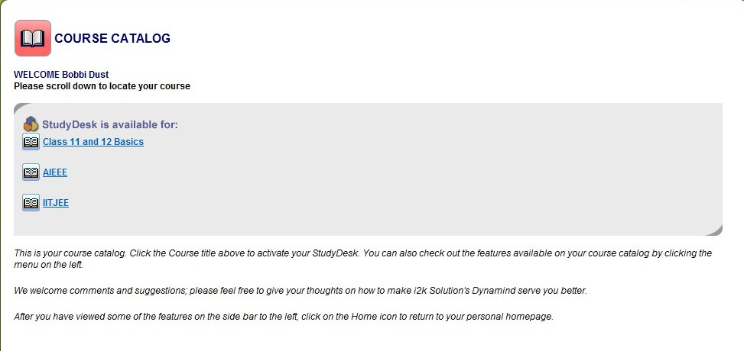
Figure 7: Course Catalog
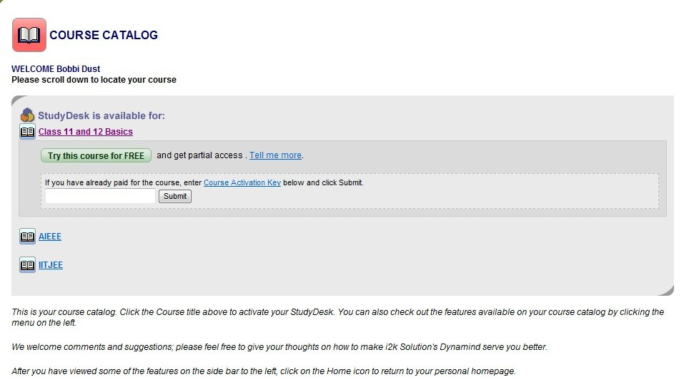
Figure 8: Select Course


Figure 9: Menu
In addition to this menu, you will also notice a list of courses for which you are registered. Your registered courses are those courses that you have selected from the course catalog. This list provides you with the date in which you registered and the date when the course will expire. Once you have located the course you would like to work on, click the corresponding link and you will be taken to that course’s StudyDesk.
Once you have accessed your StudyDesk, you will be presented with pertinent information regarding your status in the course. You have the option of opening your class, re-visiting the key concept you last visited, or take the StudyDesk tour to review its features. In addition, your updates are listed on the right.
These updates consist of any replies from experts, your current ranking, your percentile score, how much of the course you’ve covered, and up to five chapters that may need your attention. These updates are for the selected class only and do not reflect your status for all classes. Figure 10 shows the main page of the StudyDesk, which includes the updates.
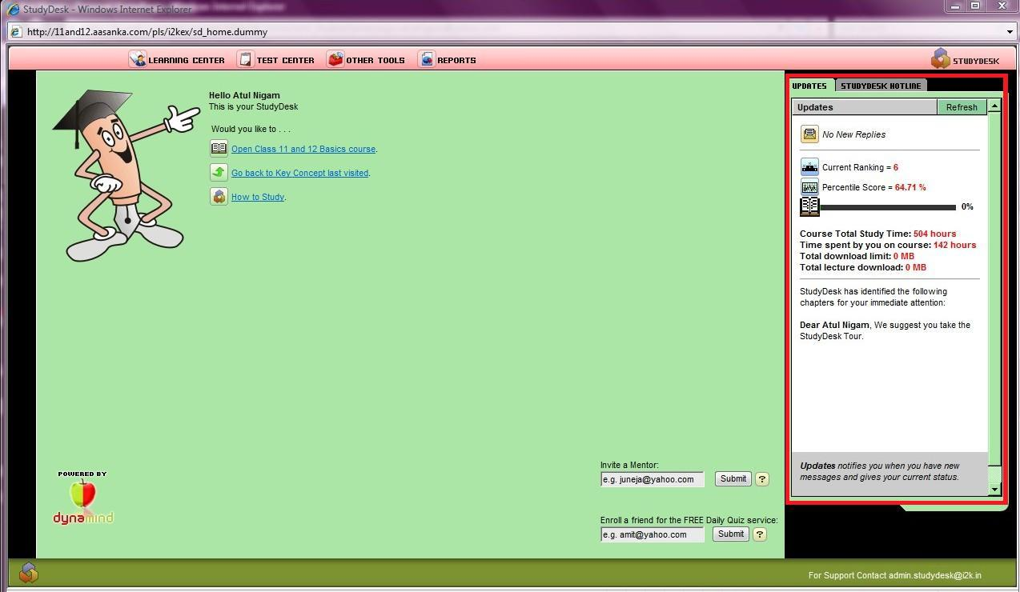
Updates
Figure 10: StudyDesk Main Page & Updates
Now we will break down the StudyDesk, icon to icon.

Open Class
Your Open Class icon allows you to do just that. Once you’ve clicked on the icon, another screen will appear. This screen allows to you choose how you want to access your course.
There are three options to choose from and your choice depends upon how you feel most comfortable learning. The first option is Instructor Led Plan, which allows moving only within the course plan designed by the instructor (see Figure 12). The second option is Flexible Study Plan, which allows movement anywhere in the course (see Figure 13).
StudyDesk Icons
- Open Class
Back to Key Concept last visited
How to Study
Replies
Current ranking
Percentile score
This option also allows you to see your strengths and weaknesses at all stages of the course. You can click on any section to see your strengths and weaknesses. The third option is Class of One, which presents your weakest areas first (see Figure 14). Once you’ve selected one option, click Submit and you will be taken to your class. Figure 11 illustrates what this screen looks like and how to make your selections. Congratulations on accessing you course!
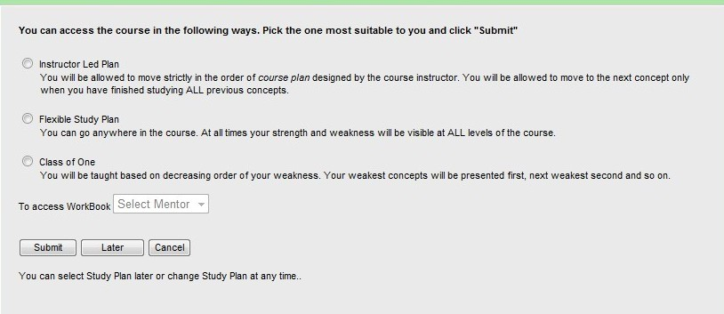
Figure 11: How to Access your Course
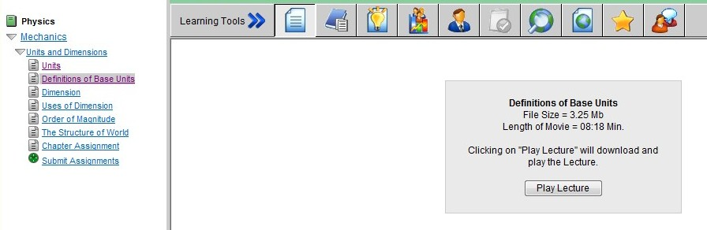
Figure 12: Instructor Led Plan
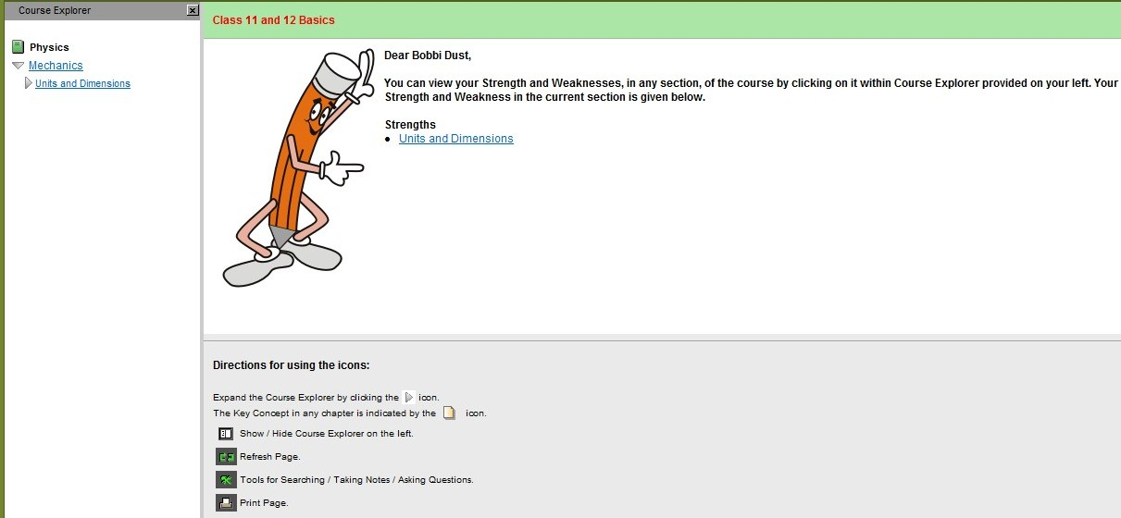
Figure 13: Flexible Study Plan
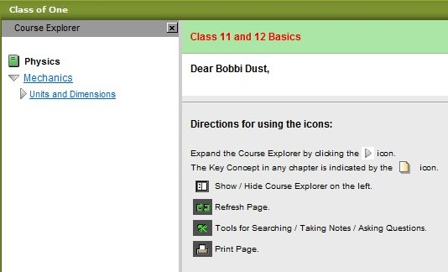
Figure 14: Class of One Plan
Now, we’re on to the next screen.

Back to Key Concept Last Visited
This option is listed under Open Class on the StudyDesk. The first time you click on the icon, you will be taken to the beginning of the course. However, once you’ve accessed this option, you will be taken to the last concept you were working on. Once you have finished the course, clicking this icon will take you to your weakest concept for further studying. Please see Figure 15 for a visual of this screen.
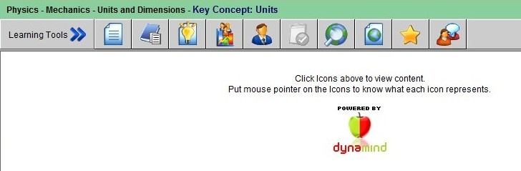
StudyDesk Icons
- Open Class
Back to Key Concept last visited
How to Study
Replies
Current ranking
Percentile score
Figure 15: Back to Key Concept
This option has many other options included. We will discuss those options now.

Learning Tools
These learning tools serve to enhance the online learning experience. We will now review each tool in-depth. Each of the learning tools also includes a picture of what that particular screen looks like. If you look to the right, you will see a list of each icon and what it represents. Figure 16 illustrates the Learning Tools toolbar.
Figure 16: Learning Tools Toolbar
View Concept 
This tool allows you to view the current concept.
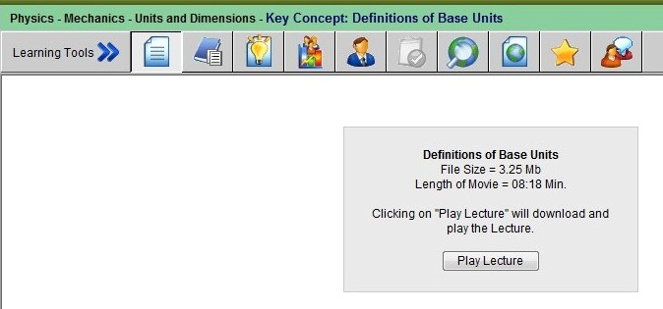
Workbook 
With this tool, you can check to see if a mentor has created a customized set of problems and study material to help you.
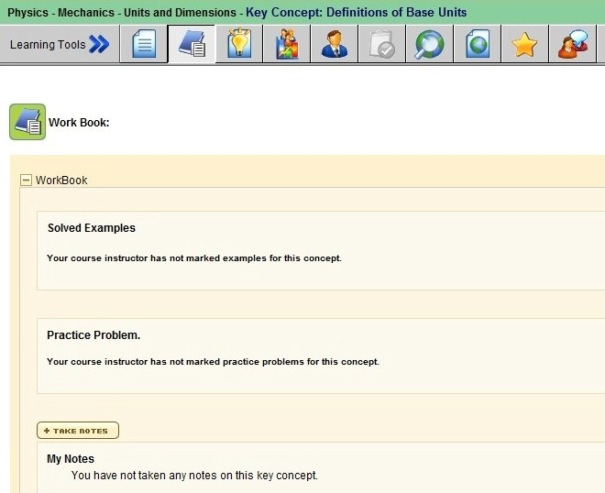
Expert Feedback 
Use this tool to see whether an expert has provided feedback on this concept.
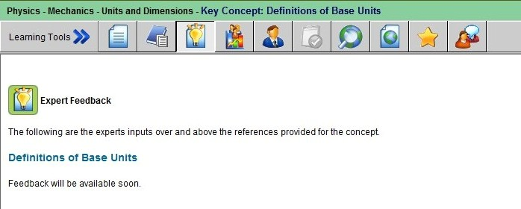
Who Knows What 
Who Knows What allows you to search for and contact another learner who has knowledge in the concept you are studying. To search for a learner who has knowledge in your concept, simply click on and send an email invitation. See Figure 8 for a sample message that the recipient will receive.
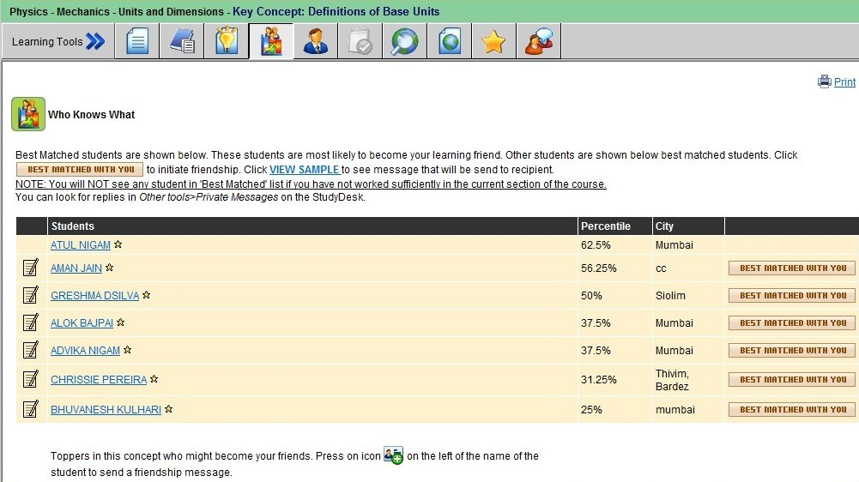
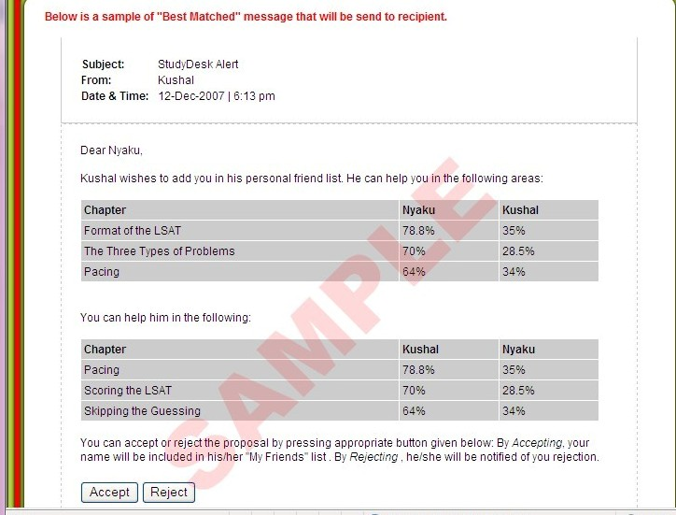
Figure 17: Sample Message

Search / Contact a Mentor 
Allows you to check and contact listed mentors who can assist you with the current concept.
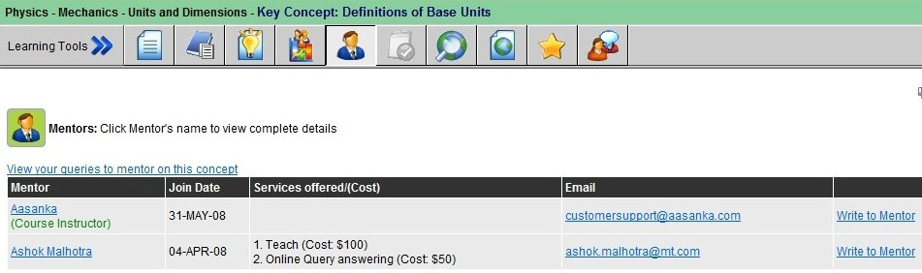

Search Internet 
Search the internet using ZenMaster. To use this feature, you must first submit a search string. Once you’ve entered this, ZenMaster will perform the search and bring back the results for you to view. As you receive your search results, you have the option of adding them to your Hotlinks.
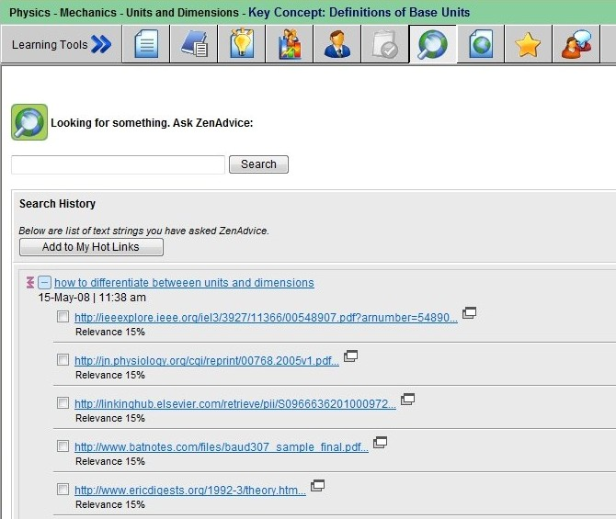

Web Links 
Internet resources that may help you better understand the concept. Your mentor(s) can also add links here that may help you. Mentor provided links appear in a different color and contain comments by the mentor.
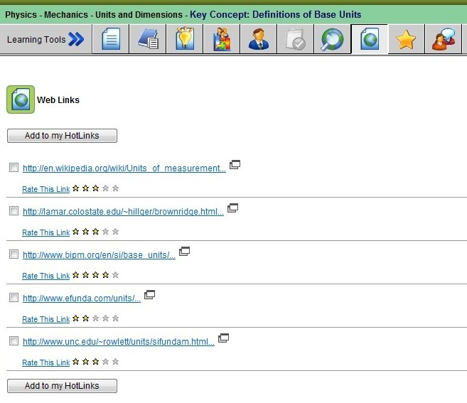

My Hotlinks 
Web links you have saved.
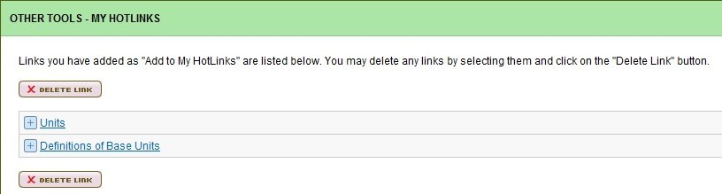
Comments 
You can view or post comments about the current concept.
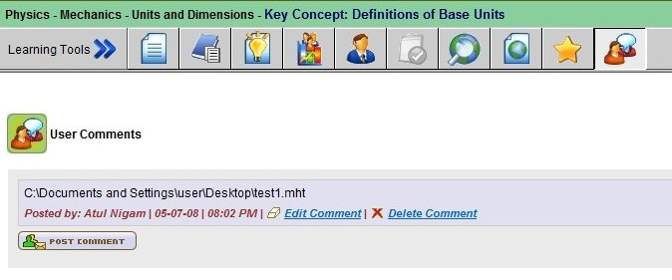

We’re now moving on to the How to Study Icon.

How to Study
Clicking the icon opens a new window and takes you to a Flash movie. This movie fully explains the use and navigation of the StudyDesk. It also highlights key areas, such as your course progress and where to find the material that needs further attention. This is a great resource to have available and should be viewed regularly.
So, that’s the StudyDesk. What do you think? There are many resources available to help you succeed in an online learning atmosphere. Please take full advantage of these resources in order to be successful in your education.
Now that we’ve thoroughly covered the StudyDesk, it’s time to move on. The next section covers the Learning Center. Are you ready? Great…here we go.

Section II Learning Center

The Learning Center can be accessed from the top of the StudyDesk page. It is listed in a header along with the Test Center, Other Tools, and Reports. Please see figure 18. The Learning Center offers three options; Go to course, Set daily quiz chapters, and view assignment. We’ll begin with the Go to Course option.
Figure 18: Access to Learning Center

Go to Course
This option is the same as the Open Class option from the StudyDesk. Remember the icon? From here, you will choose your class type – instructor led, flexible study plan, or class of one. We’ll that’s it for this option. Now it’s on to set daily quiz chapters.

Set Daily Quiz Chapters
This option allows you to set the chapters for which you’d like to receive daily quiz questions. To select chapters, simply select the box next to each chapter so that a check mark appears. Once you’ve selected all the chapters you wish to receive quiz questions for, click on Set Daily Quiz. Figure 10 shows what the screen for the main page of this section looks like. Please refer to Figures 19- 22 for additional steps.
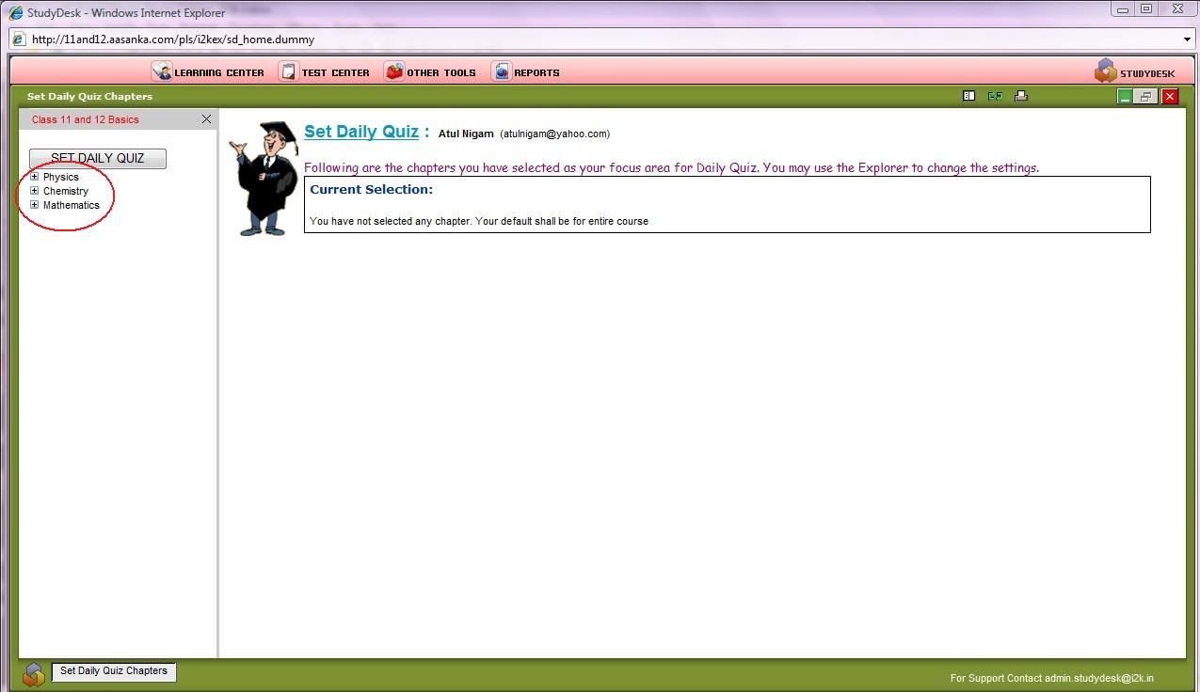
Select your chapters by clicking the + sign next to each subject. Then select each subject you want to be quizzed by placing a check mark in each box.
Figure 19: Set Daily Quiz Chapters Main
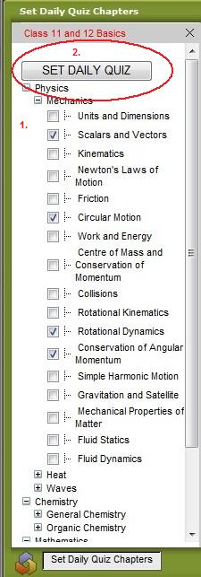
- Select quiz chapters
- Click Set Daily Quiz
Figure 20: Selected Quiz Chapters
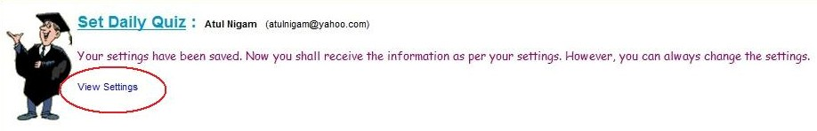
Figure 21: View Settings Option
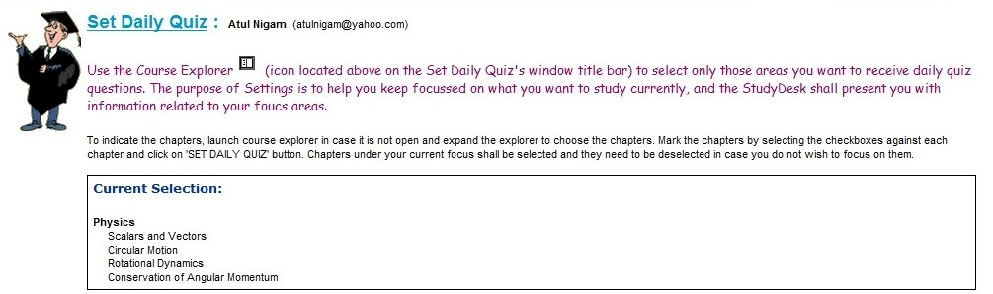
Figure 22: Viewing Settings

Now that you’ve successfully selected your daily quiz chapters, let’s move on to view assignment.

View Assignment
This section of the Learning Center allows you to see all of your assignments. From this screen you have many options. You can elect to click on the name of the assignment to see, at once, all of the problems that are included. To the right of each assignment are two buttons – Mentor Mode and Test Mode (see Figures 23 and 24).
Mentor Mode allows you to immediately see the correct answer after you’ve answered the question. Test Mode allows you to see all of the correct answers for an assignment after it’s been completed by you.
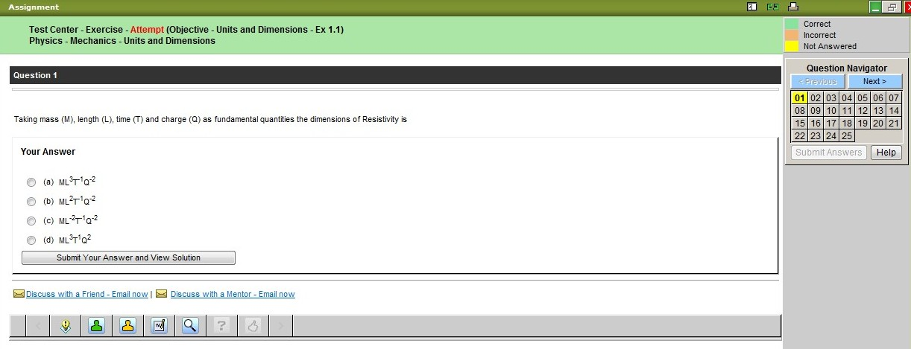
Figure 23: Mentor Mode
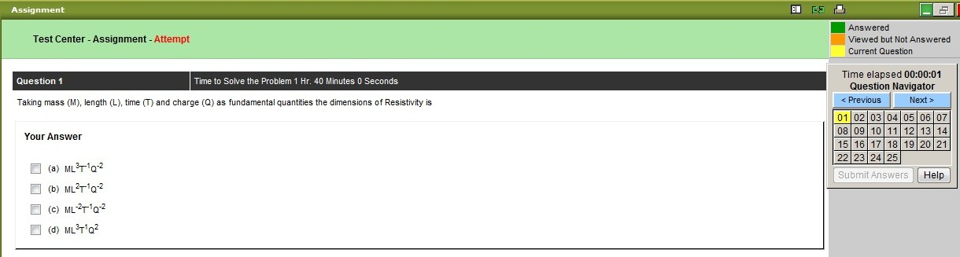
Figure 24: Test Mode
There are different types of assignments – Objective, Subjective and Thought Type. We will begin with Objective assignments.

Objective
After clicking on your objective assignment, you will see a pop-screen appear. Within this screen there will be questions for you to answer. These types of questions resemble math-type problems. Please refer to Figure 25 for more details.
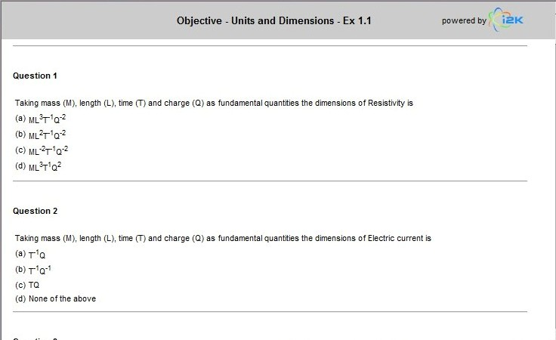
Figure 25: Objective Assignment
The objective assignment also allows you to submit your answers for immediate feedback. To submit you assignment, simply click on Submit Answers on the right (see Figure 26). Once you have submitted your answers, you can view the report to see your weak areas. You may also attempt the assignment again (see Figures 27 and 28).
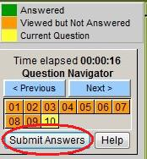
Figure 26: Submit Answers

Figure 27: Successful Assignment Submission
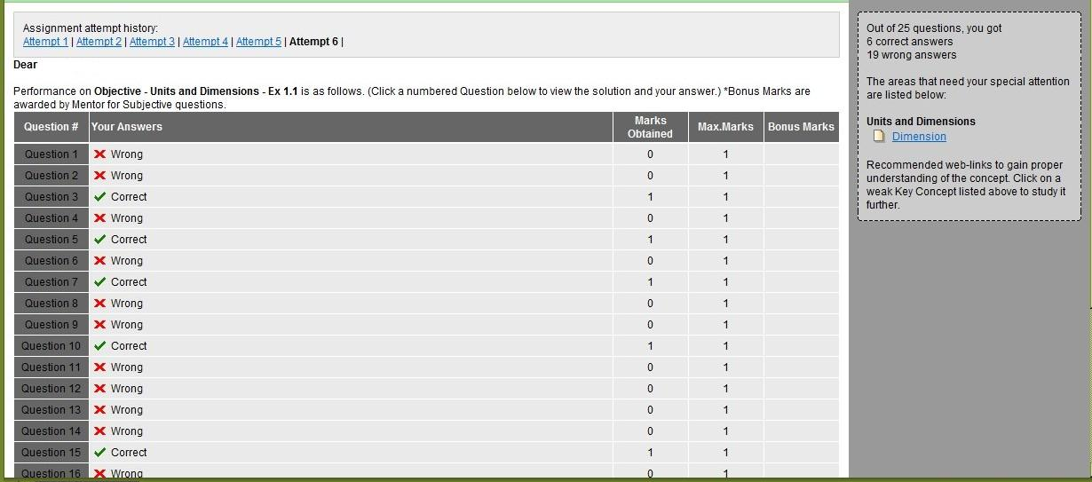
Figure 28: View Report

Subjective
As with the objective assignments, clicking on the Subject assignment link will generate a pop-up screen. This screen is similar to the Objective assignment screen but contains fewer and different questions. Figure 29 is a visual of the Subject assignment screen.
Figure 30 represents the counter by which the test is measured. On this counter, you will notice a clock making you aware of how much time you have spent on the test and how many questions there are. You will also notice three different colors in the legend. These colors represent the questions that have been viewed but not answered, the questions answered, and the current question.
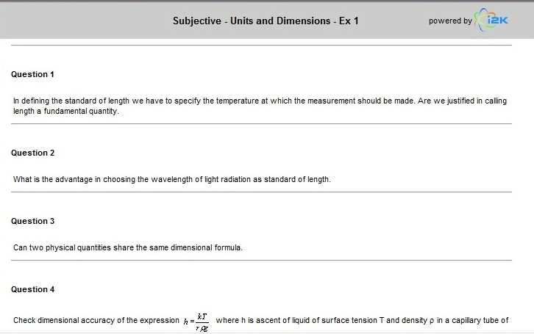
Figure 29: Subjective Assignment
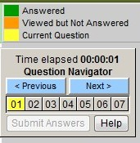
Figure 30: Test Counter & Legend
The subject assignment varies slightly from the objective assignment. This assignment is more thought based (see Figure 31). This assignment contains two (2) steps. Step 1 requires you to select the concept on which the question is based from a pop up window.
Choosing the concepts is easy. You simply click the arrow next to the topic and put a check mark in the concept(s) you feel are correct. Once you’ve selected the concepts, they will appear under the Step 1 section of the assignment (see Figure 33). Step 2 requires you to type in your response. You can also scan and upload your answers if you completed this assignment offline. StudyDesk will provide you with immediate results for steps 1 and 2 but uploading your answers requires mentor evaluation. Once the mentor has evaluated your responses, the marks will appear as bonus marks  in the assignment report.
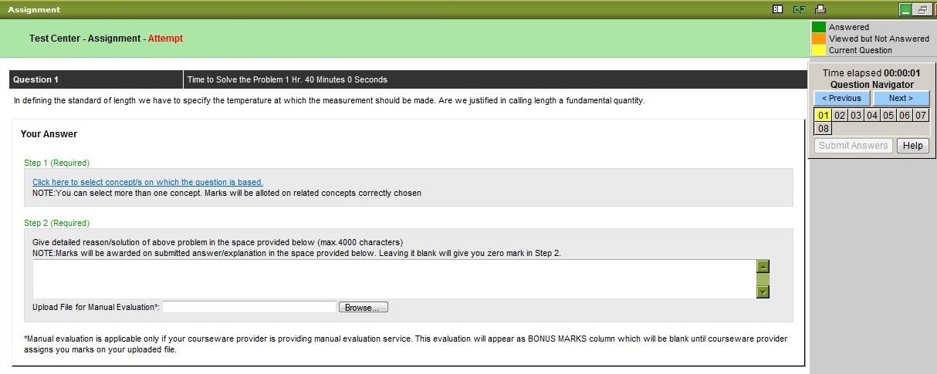
Figure 31: Subjective Assignment Attempt Main
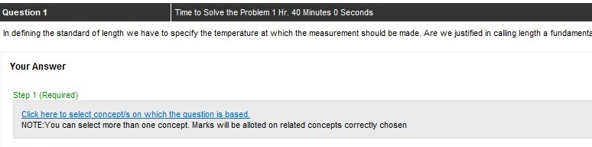
Figure 32: Step 1
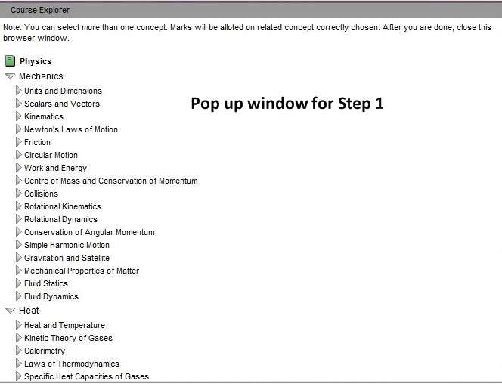
Figure 33: Pop up window for step 1
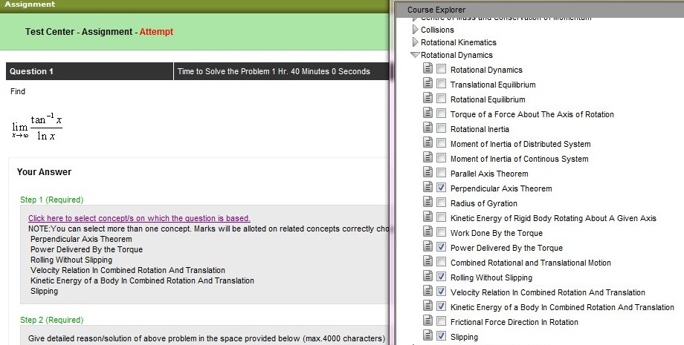
Figure 34: Choosing Concepts
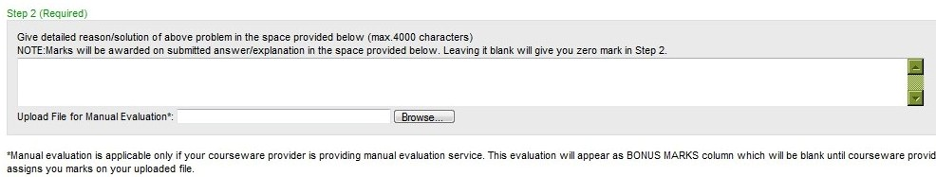
Figure 35: Step 2
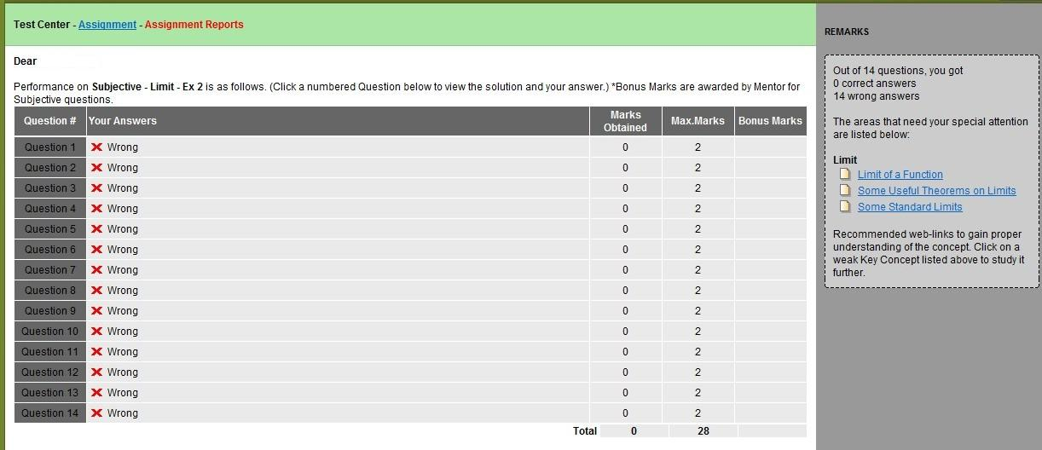
Figure 36: Submitted Subjective Assignment

Thought Type
Thought type questions are more like discussion questions. These questions are relevant to the chapter and help to provide you with a better understanding of the material. This screen, as with Objective and Subjective assignments, is generated as a pop-up. The questions contained are similar in nature to the Subjective assignment questions but contain fewer questions. Please see Figure 37.
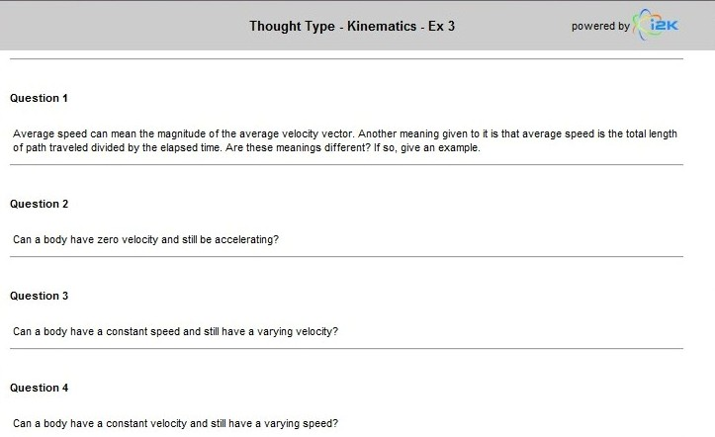
Figure 37: Thought Type Assignment
Thought type assignment is very similar to the subjective assignment (see Figure 38). Each of these assignments allows you to view the report after the assignment has been submitted. From here you can view your weaknesses.
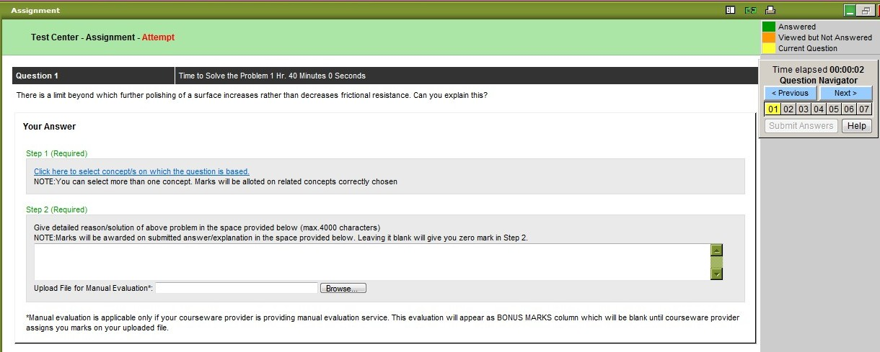
Figure 38: Thought Type Assignment
Once you’ve completed the assignment, you’ll see a different button – View Report. This button replaces the Mentor Mode and Test Mode buttons once the assignment has been completed. Clicking this button allows you to review your answers for the assignment. See Figure 39.
To attempt an assignment again, simply click on the “Attempt Again” button. Using this feature allows you to re-take an assignment that has already been submitted. You will receive personalized feedback upon re-attempt.
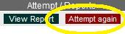
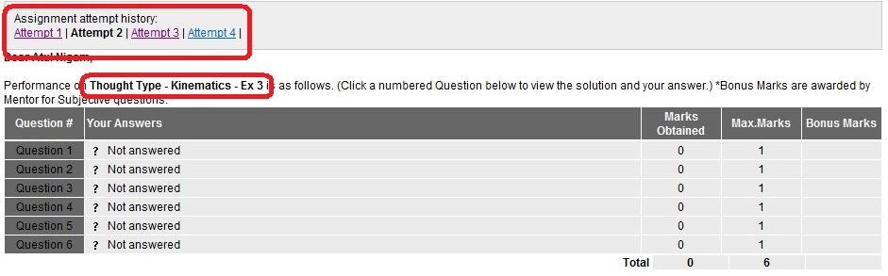
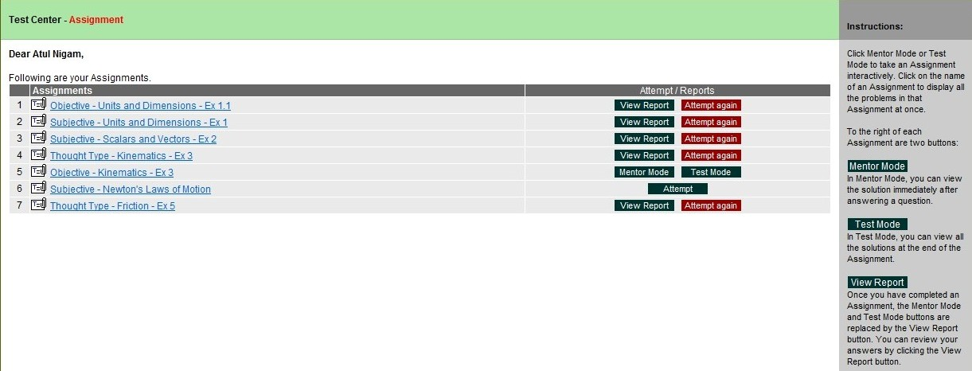
Figure 39: View Assignment
That’s the Learning Center. Are you ready to move on to the Test Center? Ok, here we go.

Section III Test Center
The Test Center is also accessed from the header on the StudyDesk. It’s located to the right of the Learning Center; see Figure 40. The Test Center has five options in the drop-down menu and they are:
- Practice Session
- View Section Tests
- View Diagnostic Test
- Daily Quiz
- Weekly Assignment
- Test Center Strategy

We will address each of these menu items individually and in detail. We will now address the Practice Session option.

Figure 40: Access to Test Center

Practice Session
This option allows you to select the subjects, topics, or chapters you would like to work on. Once you’ve made your selections, click next to be taken to the next screen (see Figure 41).

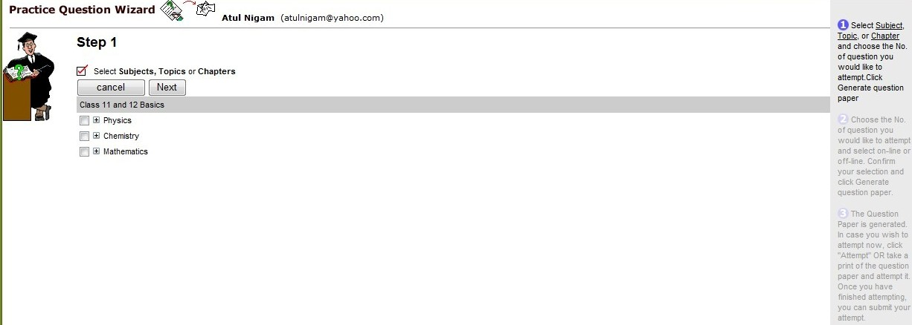
Figure 41: Selected Chapters
Once here, you will be instructed to select the number of questions you would like to answer. You can choose to answer 1 or 15 questions (see Figure 42).
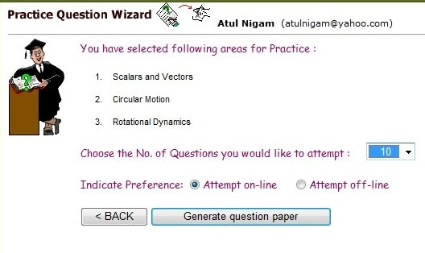
Figure 42: Select Number of Questions
Once you’ve set your number of questions, select whether you would like to do the practice session on-line or off-line and click on Generate question paper.

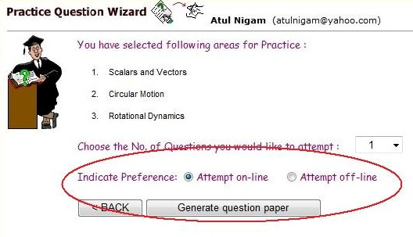
Figure 43: Practice Session Preference
If you elect to attempt your session off-line, you can print your generated questions and submit them once you’re finished.
However, if you would like to take your practice session online, you will receive immediate feedback. See Figures 43 and 45 for online practice session visuals.
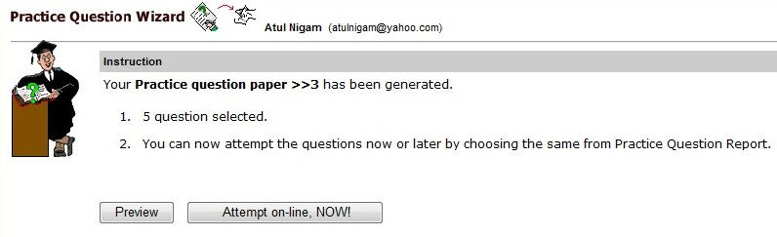
Figure 44: Online Practice Session
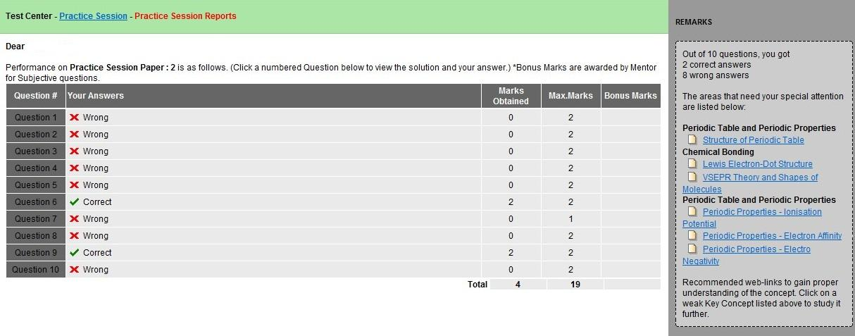
Figure 45: Practice Session Feedback

View Section Tests
This menu item allows you to view the tests for each section, if any. This area is just like the View Assignment option in the Learning Center. It comes equipped with the Mentor Mode, Test Mode, and View Report buttons.
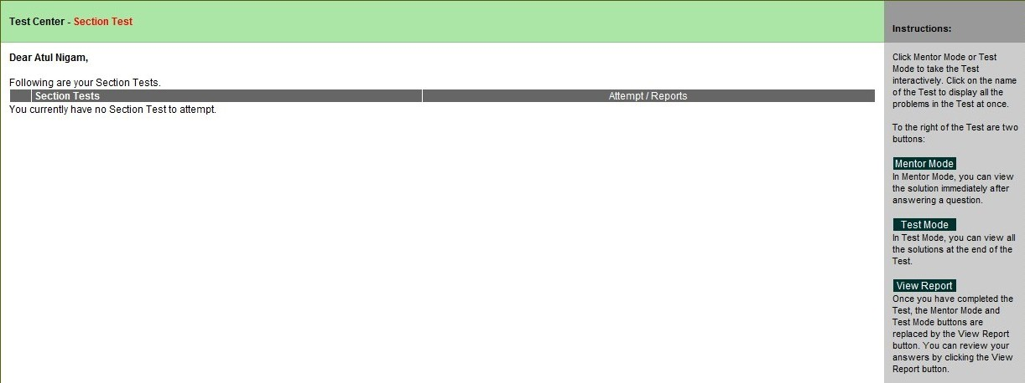
Figure 46: Section Tests

View Diagnostic Test
This section is also like the View Assignment in the Learning Center and the View Section Tests in the Test Center. It also has the Mentor Mode, Test Mode, and View Report buttons.
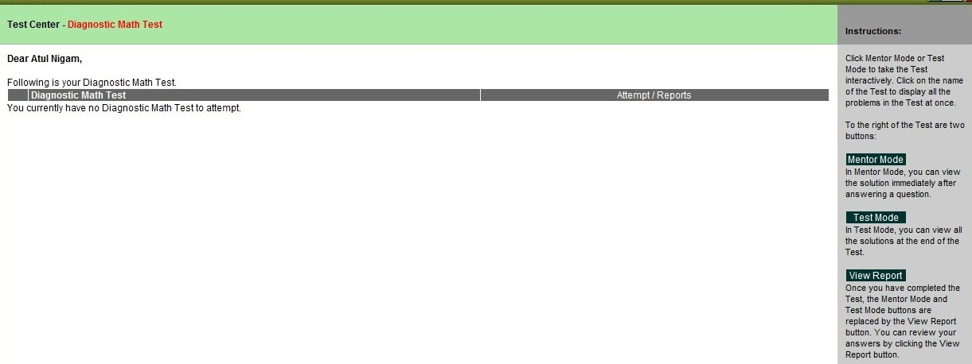
Figure 47: Diagnostic Test

Daily Quiz
This section differs a bit from the previously mentioned tests. This section contains all of the daily quizzes you’ve set up. As with the other tests, you can click on the name of the quiz to see all of the problems at once. However, this section only has two buttons – Attempt and View Report.
To take the daily quiz, click the Attempt button. This will allow you to answer all of the problems and see the correct answers at the end. Once the quiz has been completed, the Attempt button is replaced by the View Report button. You can use this button to see your answers to the quiz questions. The daily quizzes are sent to your email address in addition to being visible on StudyDesk. Please refer to Figure 48.
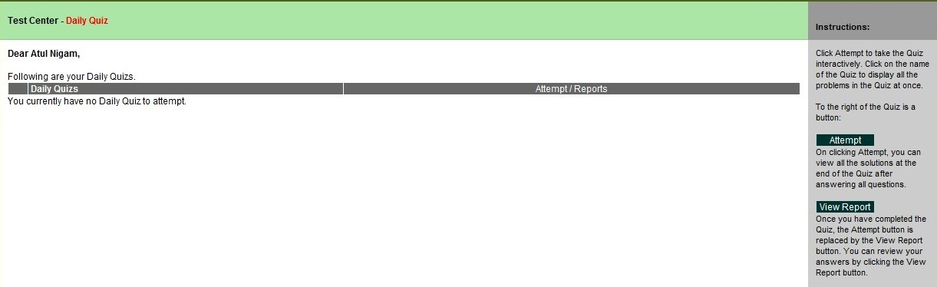
Figure 48: Daily Quiz

Weekly Assignment
The weekly assignment section allows you to attempt your weekly assignments. This section also has the Attempt and View Report buttons and works like the daily quiz. To see the complete list of problems at once, click on the assignment name.
To complete the assignment, click on Attempt. Once you’re finished, you can review your answers by pressing the View Report button. These assignments are generated weekly based on your weaknesses. Your assignments are sent to your email address in addition to being visible on StudyDesk. Figure 49 illustrates the appearance of this screen.
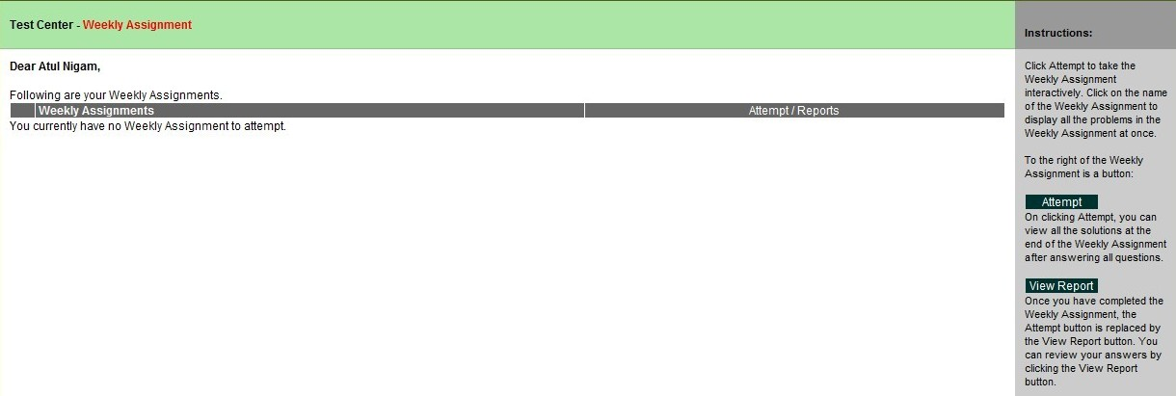
Figure 49: Weekly Assignment

Test Center Strategy
This section analyzes your strengths in the areas of your courses. To maximize your tests, choose those questions which are the easiest to you. It is highly recommended that you focus on your strengths to maximize these tests. You can select any area to see your strengths. For a view of this screen, please refer to Figure 50.
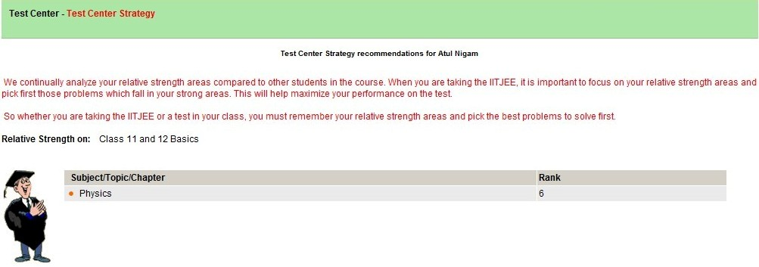
Figure 50: Test Center Strategy

Well, that’s the end of the Test Center. It’s now time to move on to Section IV – Other Tools.

Section IV Other Tools
This section addresses the Other Tools part of the StudyDesk toolbar. This option is located to the right of the Test Center (see Figure 51) and contains six additional options. Most of the options in Other Tools are designed to help you better understand the material in your course(s). The six additional options contained in Other Tools are:
- Take Notes
- My Notes
- My Questions
- Private Messages
- Friend in Need
- My Hotlinks

Figure 51: Access to Other Tools
Let’s begin with Take Notes.

Take Notes
Note taking could be one of the most beneficial tasks to learning, whether learning online or in a traditional setting. Once you click on this option a note pad opens for you to type in your notes. This screen is referenced in Figure 52.
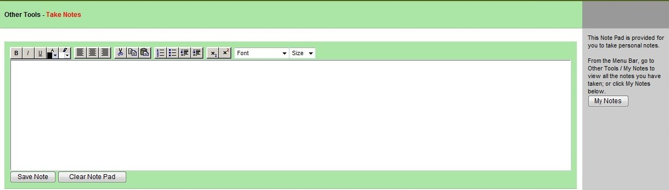
Figure 52: Take Notes

My Notes
This section is similar to the Take Notes section except you can only view your notes here. Each note is numbered and includes the date it was created. This section also lists the source of the note and the action. To view this screen, please refer to Figure 53.
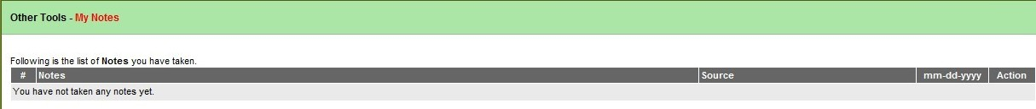
Figure 53: My Notes

My Questions
This section is very similar to My Notes but with questions instead. Every question you pose to an expert is listed here. In addition, all replies to your questions are also listed. Each question is numbered and includes the date it was created. The My Questions screen can be seen in Figure 54.
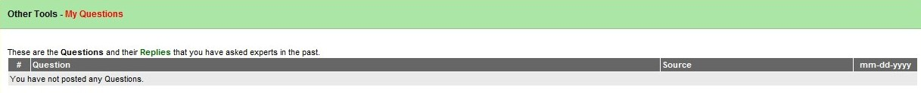
Figure 54: My Questions

Private Messages
This section serves as an inbox for all messages sent to you by your friends. You can read, compose, and delete messages here. Also visible is your friends list and a link for Friend in Need, which will be addressed next.
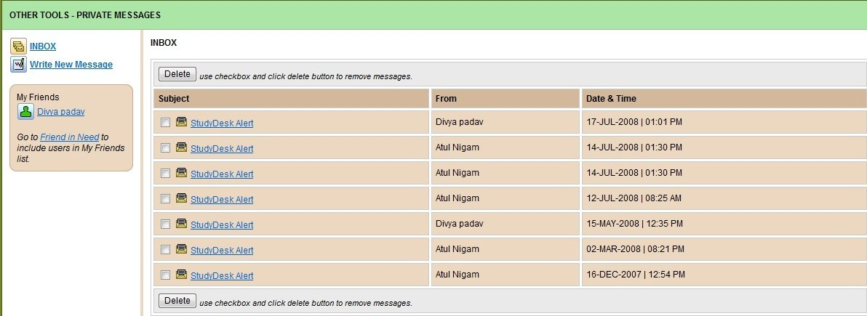
Figure 55: Private Messages

Friend in Need
This section contains a list of all students and those who are best matched with you. In initiate a friendship, simply click on the button on the far right, see Figure 56. In addition to the students’ names, their percentiles and locations are also listed.
To send messages to friends, simply click the link to the corresponding name and a pop-up screen will appear (see figure 57). In this screen, you can type in your personal message and click Submit. Your message will be sent to the other student. This section also contains a list of all students who have accepted your friendship invitations and friendship requests sent to you by other students.
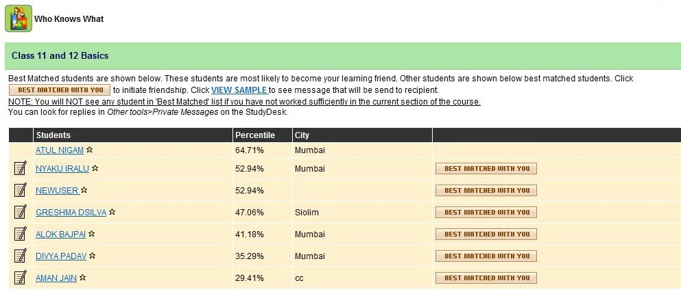
Figure 56: Friend in Need

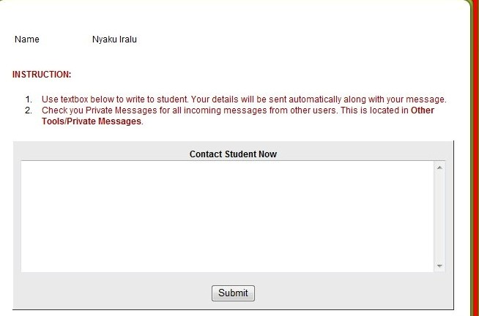
Figure 57: Private Message

My Hotlinks
This section displays all web links you have added to your Hotlinks or favorites. You can delete any links here by selecting the link to be deleted and clicking on Delete Link. Refer to Figure 58.
Figure 58: My Hotlinks
Now that we’ve completed the review of Other Tools, it’s time to move on to Reports. This is our next to last section.

Section V Reports
The Reports section contains three additional tools, which are based upon student activity and is located to the right of Other Tools (see Figure 59). This section allows you to determine your rank and how much time, in hours, you’ve spent on your course(s). The three additional tools are:
- My Rank
- Practice Session Reports
- Time Spent
Figure 59: Access to Reports

My Rank
This section allows you to see your rank and how it has changed. The rank table is color-coded with green being an improvement, red being a reduction, and black representing no change in rank.
Your rank is calculated by evaluating your performance on StudyDesk compared to that of other students. Your rank is dependent upon you and other students. For example, if a few students aren’t doing so well, your rank may increase because their rank has decreased. Refer to Figure 60 on page 43.
Your rank is configured daily by course, subject, topic, and chapter. To see your rank for each course, subject, topic and chapter, simply click on the links to the left. Your rank will be shown along with how your rank is calculated. Please see Figure 61.
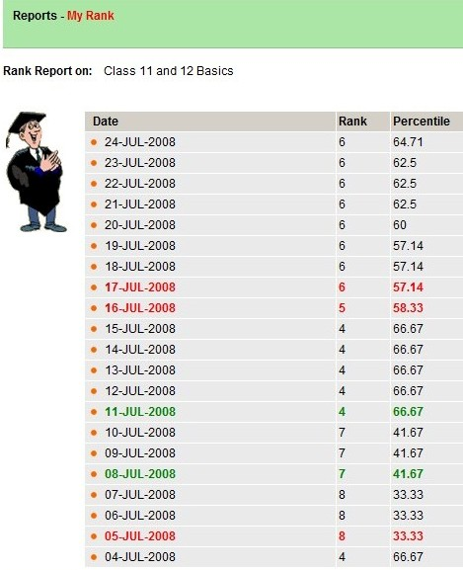
Figure 60: My Daily Rank
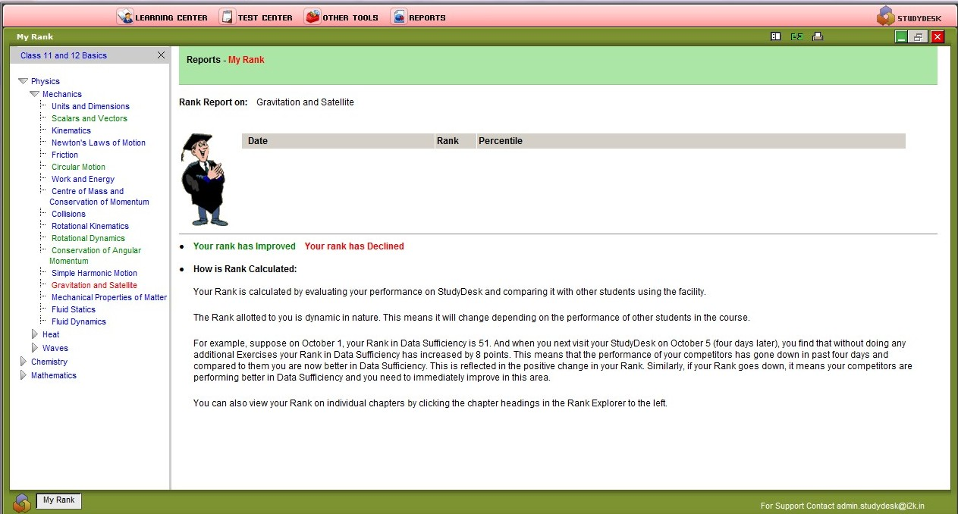
Click on a link to see your daily rank.
Figure 61: Detail Rank

Practice Session Reports
This section displays the practice tests you have completed. Each practice test is numbered and contains the date it was taken. Also in this section, you can click on the button to generate another practice test using the Practice Session Wizard. You can also review your answers to the practice test from this section. Please refer to Figure 62.
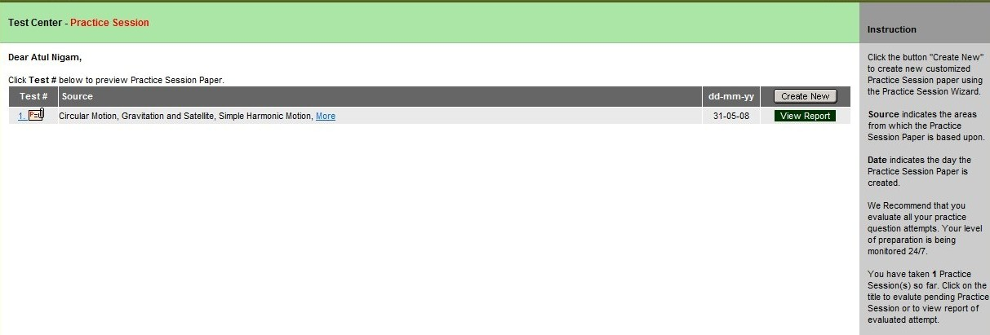
Figure 62: Practice Reports

Time Spent
This section is fairly self-explanatory. This section displays the amount of time, in hours, you’ve spent on StudyDesk. It also shows the time that was allocated for you by a mentor. Your Time Spent screen is visible in Figure 63.
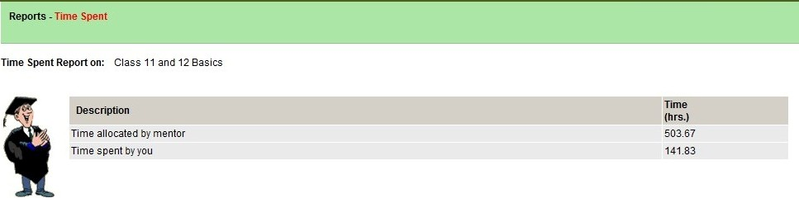
Figure 63: Time Spent
So, that’s the end of the review of the StudyDesk. Now, we’re going to move on to tips on how to study. The next section will provide you with study tips and techniques that will help you succeed in an online learning environment.

Section VI How to Study
This is the final section of this manual and focuses only on how to study in an online environment. Because learning in an online environment is different than a traditional setting, some people find it more difficult to study. This section will provide you with study tips and techniques that will help you be more successful in your continued education.

Study Tips
There are a few tips to making studying more efficient and effective in an online environment.

Find a quiet place
Studying in a quiet place will allow you to focus on your studies and only your studies. You will not have to deal with constant distractions.

Practice good time management
Time management is very important when in an online learning environment. Without good time management skills, you’re likely to forget assignments or constantly feel rushed. Always allow more than enough time to complete assignments because mistakes often happen when you’re rushed.

Organization
Organization is also very important because you must always know where your materials are. This also increases your productivity because you’re not spending valuable time looking for your materials.

Tell your family and friends about continuing your education
By informing your friends and family about your educational goals and the times in which you study, you’ll gain support. This is particularly important if your friends and family are often distracting.
Now that you’ve gotten some basic study tips, come up with some that suit your particular needs. Remember, education is important and studying is part of your education. We’re now going to move on to a few study techniques that can also help you succeed.

Study Techniques
How you study is just as important as when and where you study. You have to study in a way that the material makes sense to you and so you can retain the barrage of information coming your way. Below are a few study techniques to get you started.

Take advantage of practice tests
Using practice tests is a great way to study your material because you can see where you went wrong. In those areas where you’re weakest, create practice tests based solely on that information. By doing this, you’ll be able to improve in that area and become more knowledgeable.

Use mentors
Mentors are people who can help you so let them. Mentors have already been where you are now and may have different techniques for remembering information that may be useful to you.

Review all test answers
By reviewing all test answers you’ll be able to determine what your weak areas are. You can also see why you got the answers wrong and how to correct them. This is important because you won’t learn much if you just sit idly by.

Find a study buddy
Oftentimes studying with a partner is a good thing because you can work together. Make flash cards and quiz each other so you can retain the information you have to study. This is the only time you should work with others while studying because distractions can easily occur if you’re not careful. In addition, working with another person can also ease the stress and tension, which can lead to better focus.
CONGRATULATIONS!
You’ve successfully finished this manual.
You now have the necessary tools to
succeed with StudyDesk and continuing
your education.

GOOD LUCK!

