WorkDesk
A Guide for Mentors

Table of Contents
Section I Home Page 5
Section II Your Profile 7
Section III Administrative Tools 9
Mentor 9
Request 10
Notice Board 10
Feedback 12
Section IV WorkDesk 13
Web Meeting 13
Tools 14
Administration 15
Student Attendance 15
Student List 18
Mentor Details 18
Student Reports 21
Current ROI Status 22
Course Settings 22
Course 23
Class 24
Course Details 25
Course Overview 26
Difficult Question Report 27
Rank Report 29
Questions Box 29
Time Spent 30
Create / Modify Test 30
Create / Modify Exercise 31
Create / Modify Mentor Exercise 32
Submit Test 32
Submit Exercise 32
Submit Mentor Exercise 33
Test Report 33
Section Test Report 33
Exercise Report 34
Student 34
Student Personal Details 34
Student Feedback 35
Rank Report 35
Student Questions 36
Weak Areas 36
Time Spent 36
Test Report 37
Section Test Report 37
Exercise Report 38
Practice Report 38

Overview

WorkDesk is an interactive learning tool which was created to assist students with the online learning process. Each student has access to Mentors whose jobs are to assist the students with course material. The StudyDesk provides the necessary features mentors need to successfully aid in the student learning process. This manual is broken down into five sections that will describe each feature and its functions. Let us begin by listing each section.
Section I – Home Page
- How to register
- Overview of Mentor’s options
Section II – Mentor’s Profile & Change Password
- Allows mentors to create a personal profile and change password
Section III – Administrative Tools
- Provides mentors with access to creating student notices
Section IV – WorkDesk
- Provides mentors with the tools required to aid in student learning

Section I Home Page

Before you can log on to your home page, you must first register as a Mentor. To do this, simply click on the Sing Up button on the far right of the page. After clicking on the sign up button, you will be re-directed to the registration page. On this page, you are required to enter your name and other personal information and then select Mentor before clicking register (see Figure 1).
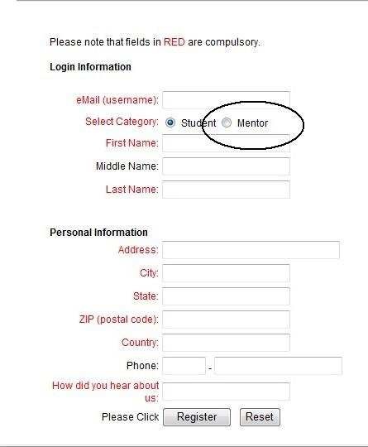
Figure 1: Registration
Once you have successfully registered, you will be able to log in to your home page, using your temporary password.
This temporary password allows you to either register for one free chapter or full access. Please note that full access to the Mentor’s WorkDesk requires payment of a specified fee. After logging on to your home page, you will immediately notice the moveable menu on the left. This menu moves as you scroll the page so it is always visible. Please see Figure 2 for a visual of this menu.

Figure 2: Menu
In addition, the home page also contains the course for which you are a registered mentor. To access this course, simply click the link next to the icon.

Under this icon and link, you will see a list of how many students and mentors are registered for the same course. Mentors are represented by the icon and students are represented by the icon. To the right of these icons are the number of registered users and the number of any new messages. The home page also contains a questions section, which shows you the number of new and/or unanswered questions from students. Replying to these questions is easy – simply click on the question to open and type your reply (see Figure 3).
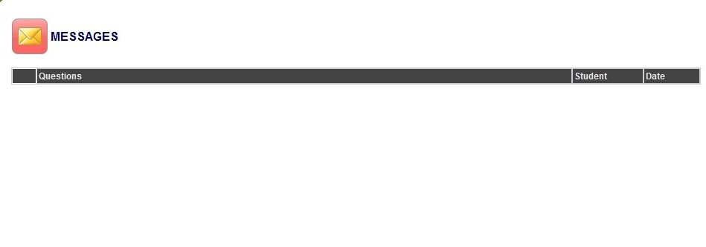
Figure 3: Questions Box
Now that you have mastered the use of your home page, it’s now time to move on to the next section – your Profile.

Section II Your Profile
Your profile contains your personal information and password. You can access your profile simply by clicking on the profile option on the moveable menu (see Figure 4).
Figure 4: Profile Menu Option
After clicking on the profile option in the menu, you’ll be taken to your profile page. Once you’ve accessed your profile, you can update or change your information and password. Be sure to click Save before exiting your profile. Please refer to Figure 5 for a visual of your profile screen.
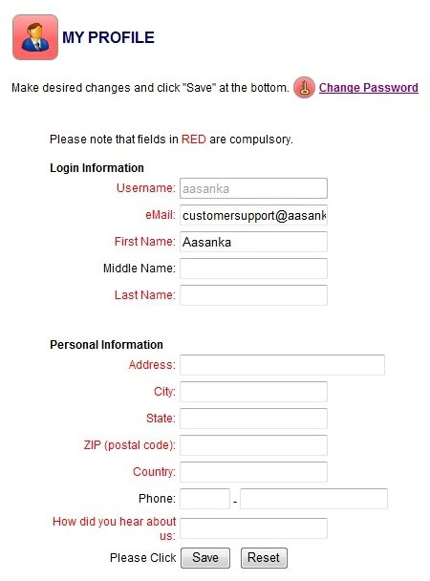
Figure 5: Profile Page
Updating your profile is very easy. Always be sure to click the Save button before exiting to ensure that your information is successfully stored. Now that we’ve fully covered the Profile section, we’re going to move on to the Administrator section.

Section III Administrative Tools
The administrative tools section contains many options for Super Mentors. To access this section, click on the button on the moveable menu. Once you have clicked this menu option, you will be taken to your administrator page. From this page, you will see four tabs at the top of the page. The tabs include: Mentor, Request, Notice Board, and Feedback. We will address each tab in-depth now.
There are two (2) types of Mentors; Super Mentor and Mentor. The Super Mentors have additional access to many features that are not available to Mentors. Please keep this in mind when reading the remaining instructions as the differences will be mentioned.

Super Mentor Features

Mentor
This tab allows you to see a list of all registered mentors and their roles, if you are registered as a Super Mentor.
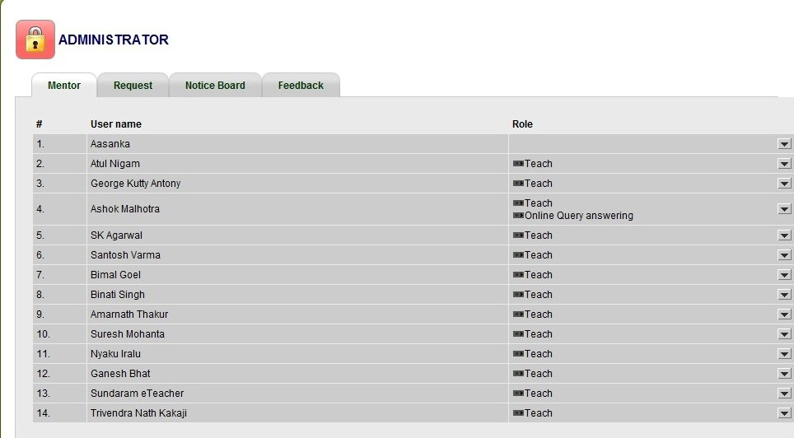
Figure 6: Administrative Tools – Super Mentor
Now that you know where to find a list of all registered mentors, we’re going to show you how to accept to deny a mentor’s registration.

Request
The second tab in Administrative Tools is Request. This tab contains the information of all mentors who have registered and are awaiting approval. From this screen, you can view the mentor’s registration information and decided whether to accept to deny registration, if you are registered as a Super Mentor (see Figure 7).
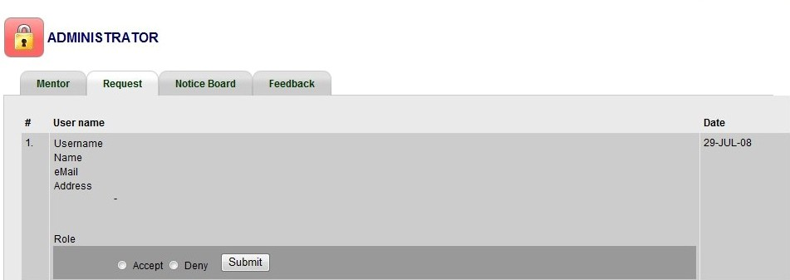
Figure 7: Administrative Tools – Request – Super Mentor

Notice Board
The notice board is the third tab in the administrative tools. This tab allows you to create or edit notices (see Figure 8). These notices also appear on the Students’ notice board. To create a new notice, simply click the button and type your notice. You will be asked to provide a title for your notice, the body of your notice, and how long you want your notice to remain active (see Figure 9).
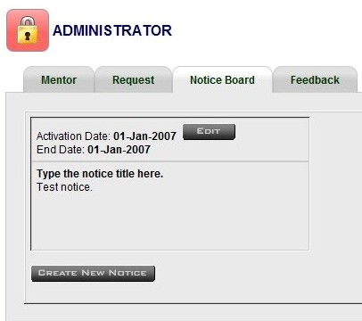
Figure 8: Administrative Tools - Notice Board
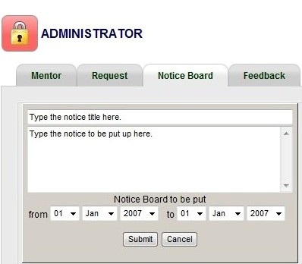
Figure 9: Administrative Tools - Create New Notice

Feedback
The feedback tab shows any questions or comments from students who have signed up but not registered for a particular course. In this section you can see the question or comment, the email address of the student, and the date which the question or comment was created (see Figure 10). To respond to a question or comment, simply click the link for the student’s email address and respond. When you click on the student’s email address, the subject will be automatically entered as “Your feedback dated [date feedback was submitted]”
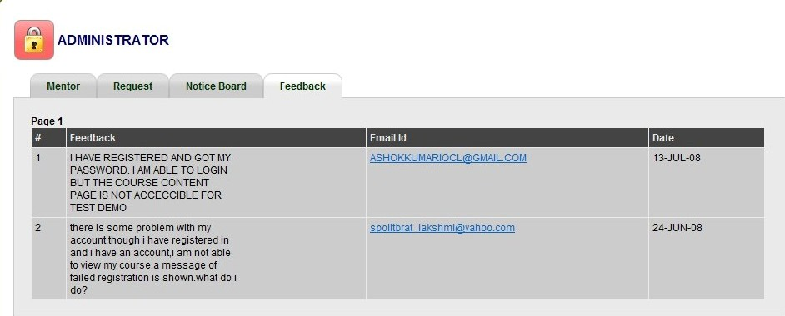
Figure 10: Administrative Tools - Feedback
Now that you’ve mastered the tools in the administrator section, we will continue with the Mentor’s WorkDesk.

Section IV WorkDesk
Remember the icon from Section I? This icon allows you to access your WorkDesk for each class you mentor. When you have clicked the link next to the icon, you will be taken to your WorkDesk. From this screen, you can see any updates, such as new questions or comments asked by students and a toolbar full of valuable resources. This toolbar contains four sections, which we will address individually. Please refer to Figure 11 to see your WorkDesk.
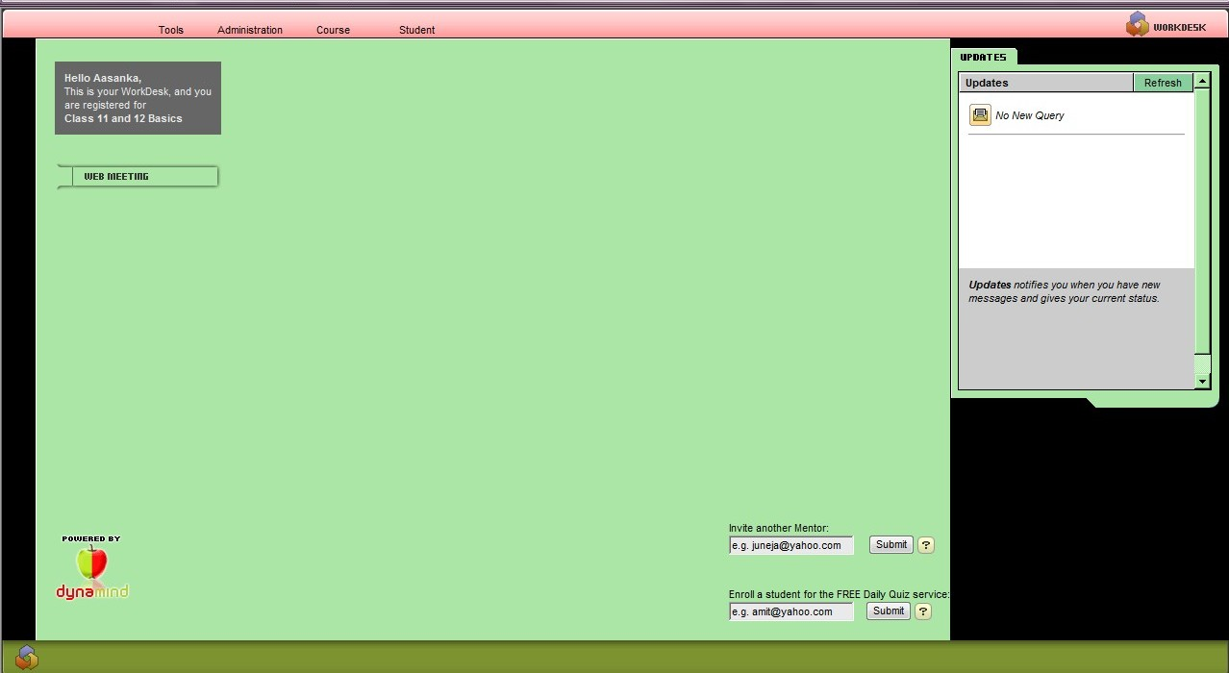
Figure 11: Mentor WorkDesk

Web Meeting
From the main WorkDesk page, you can initiate a web meeting simply by clicking the button. Once you click on the Web Meeting button, a new window will open. Opening in this window is the web meeting site that allows you to start a meeting and invite attendees. DimDim is the platform used for web meetings.
As you may have noticed, your WorkDesk has a toolbar at the top. This toolbar contains several resources available for your use. There are four sections to this toolbar – Tools, Administration, Course and Student (see Figure 12).
Figure 112: WorkDesk Toolbar

Tools
This section contains three options – My Hotlinks, Reload WorkDesk, and Exit. My Hotlinks is where you save your web links as favorites (see Figure 13).
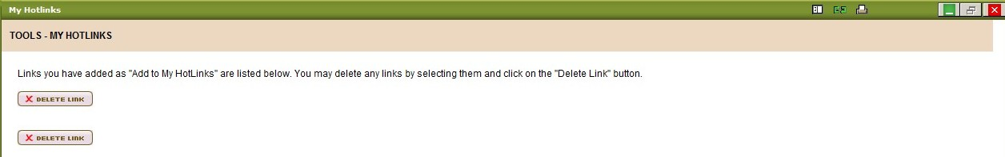
Figure 123: Tools - My Hotlinks
You can delete any links here by selecting the box next to them and clicking the button.
Clicking the Reload WorkDesk button refreshes your screen so you can keep your updates current. This option refreshes the entire WorkDesk. If you only want to refresh your updates, simply click the Refresh button next to your updates (see Figure 14).
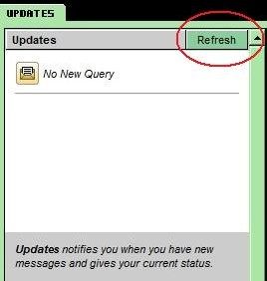
Figure 134: Updates Refresh
By selecting the Exit option from the Tools menu, you will exit your WorkDesk and be taken back to your home page.
Now that we’ve fully discussed the Tools option, we’re moving on to the Administration option.

Administration
This option contains seven additional options:
- Student Attendance
- Student List
- Mentor Details
- Mentor Request
- Student Reports
- Current ROI Status
- Course Setting

Student Attendance
This option allows you to see which students have logged in since your last visit. Student visits are marked by a and may have a number in parenthesis next to it (see Figure 15).
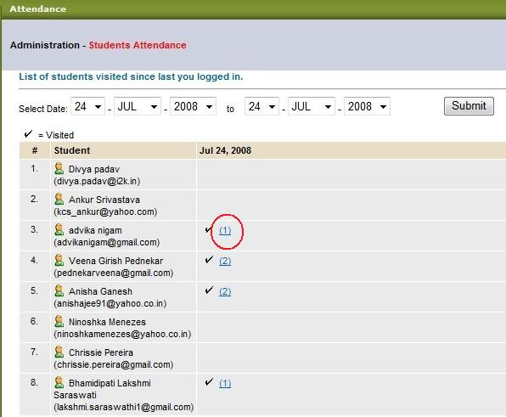
Figure 145: Student Attendance with Number
The number inside the parenthesis indicates the students’ activities during the successful log in. To see the students’ activities, simply click on the number and a new window will open (see Figure 16).
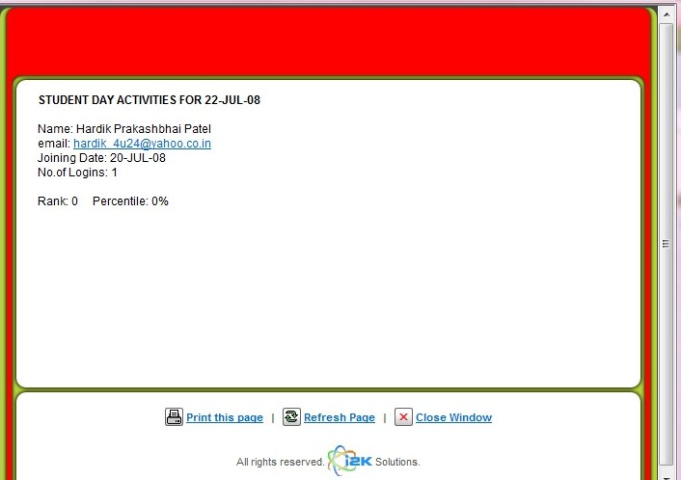
Figure 156: Student Day Activities
However, you can also see which students have logged in at any given time by selecting the dates you wish to view (see Figure 17).
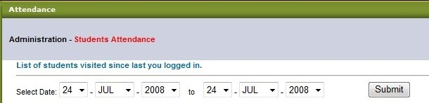
Figure 167: Search Student Attendance by Date
We’re going to move on to the next section of the Administrative option – Student List.

Student List
In this section you can view all students who are registered for a class. You can also view each student’s location, StudyDesk status, enrollment date, and expiry date (see Figure 18).
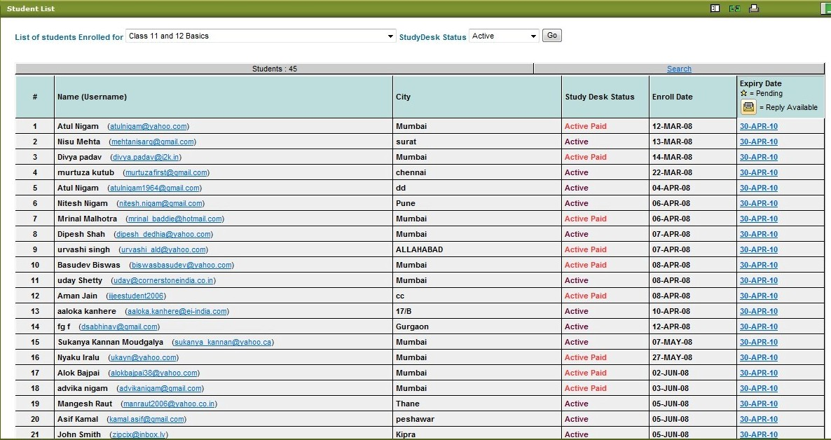
Figure 18: Student List
You can also view the student list by using the drop down menus above (see Figure 19). The drop down menu allows you to select any class and any StudyDesk status.
Figure 19: Search Student List
The next option under Administration is Mentor Details.

Mentor Details
This section allows you to see a list of all active mentors, join dates; view roles, student links, and student list (see Figure 20). Active students are those whose course has not expired. However, if you select to view Include Inactive, you will be shown a complete list of all students, even if their courses have expired (see Figure 19).
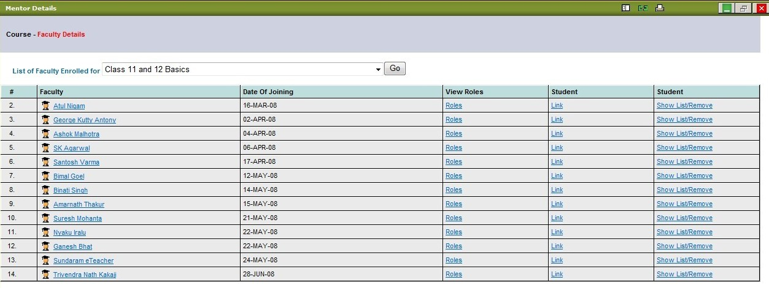
Figure 20: Mentor Details
To receive more information on the roles of each mentor, click the link entitled Roles next to each mentor’s name (see Figure 22). Once the link has been selected, you will be directed to the roles of the selected mentor, if you are registered as a Super Mentor. If you are a Super Mentor, you can use this list to select the roles of other mentors and set the fees that the mentors can charge (see Figure 21).
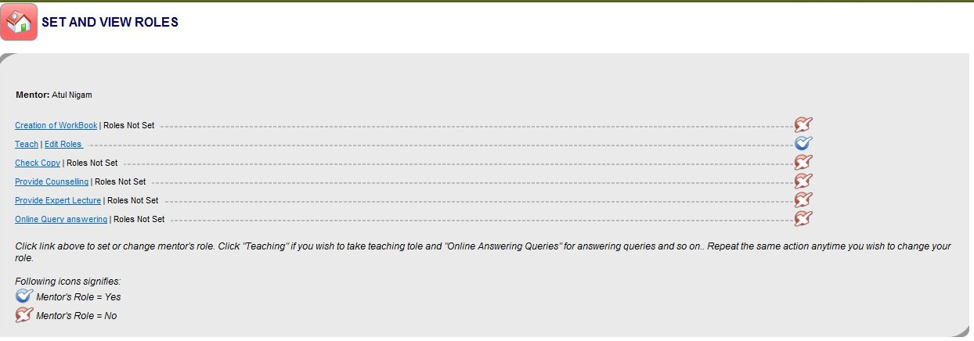
Figure 21: Set and View Mentor Roles
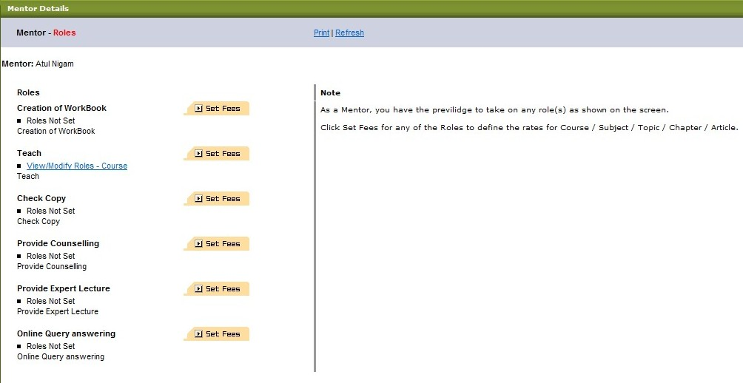
Figure 172: View Mentor Roles
To see the students for each mentor, click the link under Student for each mentor (see Figure 23).
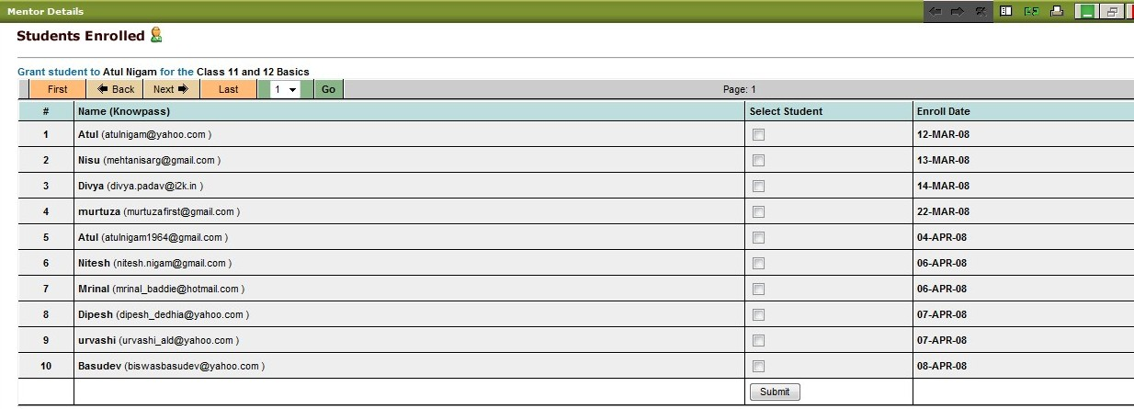
Figure 183: View Mentor Students
To remove students, click the link entitled Show List/Remove in the far right column (see Figure 24).
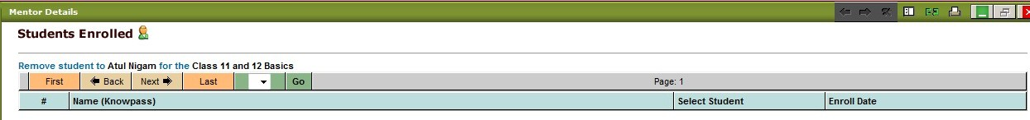
Figure 194: Show List/Remove
We’re now going to move on to the Mentor Request section.
Mentor Request
This section shows you which people have completed the mentor registration process. You can view their name, username (email address) and determine if they should become active. To make a potential mentor active, simply place a in the box next to their name and click submit (see Figure 25).
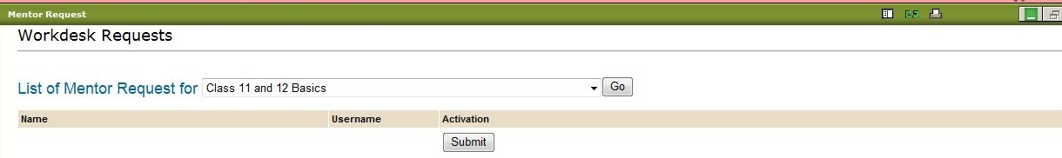
Figure 205: Mentor Request
You can also view pending mentors for other classes by selecting from the drop down menu and clicking the GO button.
Now that you know how to view other mentors and their roles, it’s time to move on to the students. The next option is Student Reports.

Student Reports
This option allows you to obtain reports on students based on different topics (see Figure 26). Each topic, when selected, will provide you with a report in a pop-up window. All reports are in PDF format.
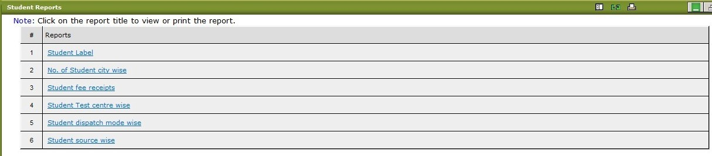
Figure 216: Student Reports

Current ROI Status
Current ROI status shows you if you are achieving your goal of helping learners. ROI stands for return on investment. Your ROI is measured in percentages and helps you identify the areas in which you are not receiving desired results (see Figure 27). When selecting this page, please be patient as it takes some time to load. In addition, you can also click on any section in the course explorer on the left to see your ROI for that section. How the current ROI status works is simple – the higher percentage loss equals higher learning loss, lower percentage loss equals lower learning loss, and zero percentage loss equals a perfect return on your investment.
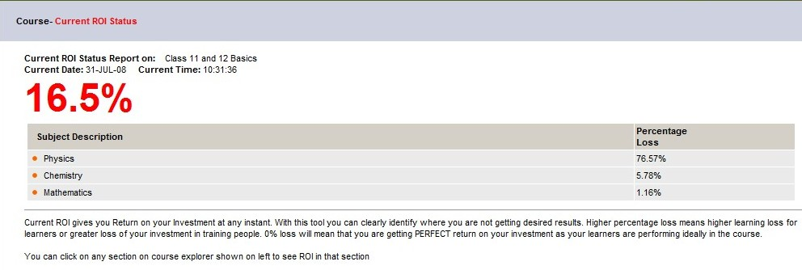
Figure 227: Current ROI Status

Course Settings
The course settings allow you to set the download limit. To set the download limit, click on the + Set Download Limit button, enter the desired download limit, and click save (see Figure 28).
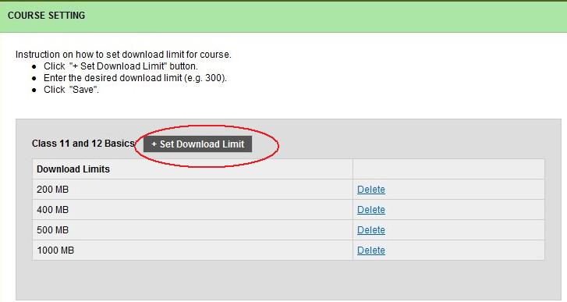
Figure 28: Course Settings
We’ve now completed the Administration section. We’re now moving on to the Course section, which contains 16 additional options.

Course
As previously mentioned, this section contains 16 additional options. These options are:
Class Details
Overview Difficult Question Report
Rank Report Questions Box
Time Spent Create / Modify Test
Create / Modify Exercise Create / Modify Mentor Exercise
Submit Test Submit Exercise
Submit Mentor Exercise Test Report
Section Test Reports Exercise Report

Class
The class section allows you to enter the selected course. From this page you can navigate to the last section or concepts page. Once there, you will be able to view all related content and edit web links (see Figure 29). From here, you can expand the Course Explorer on the left and work on many tools (see Figures 30 and 31).
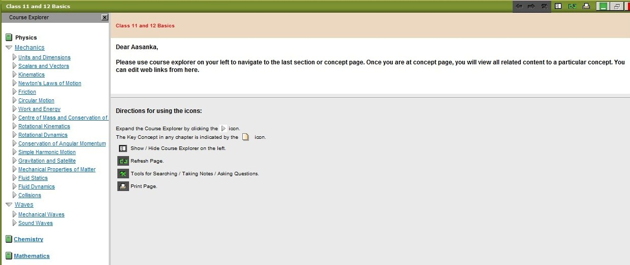
Figure 29: Class Page
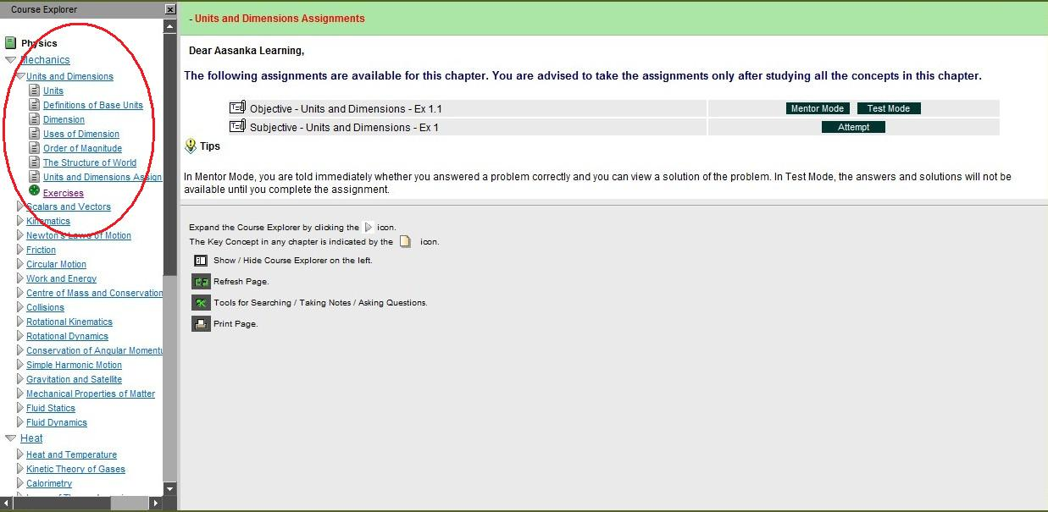
Figure 30: Expanded Course Explorer

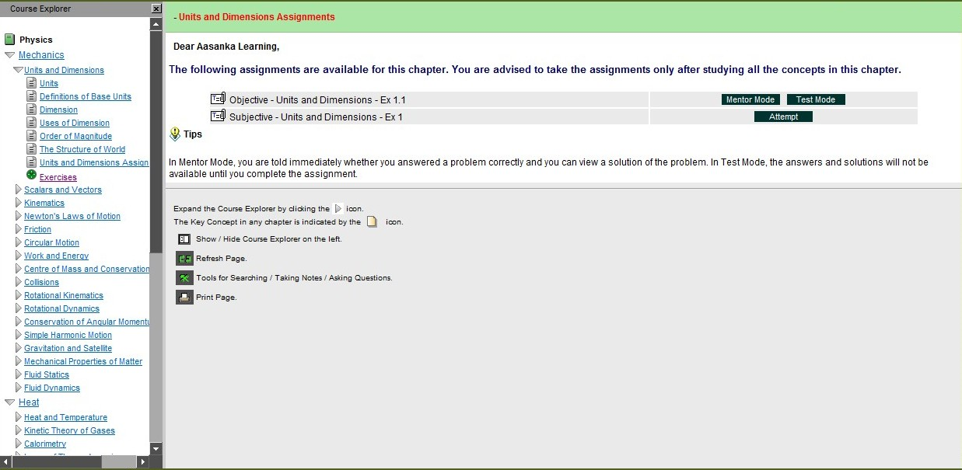
Figure 31: Exercise Option Selected

Course Details
You can also view the course details. The course details provide you with the instructor’s name, the faculty enrolled, and the number of students enrolled (see Figure 32).
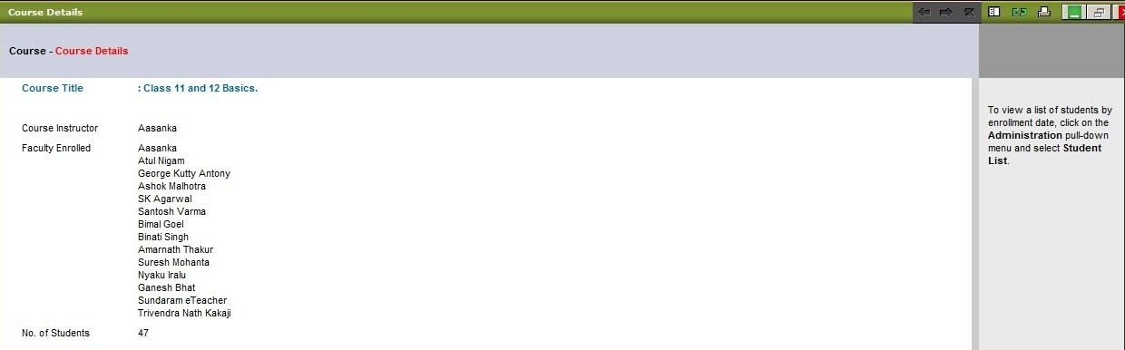
Figure 32: Course Details

Course Overview
The Course Overview provides you with the syllabus of the course. From this screen (see Figures 33), you can each section of the course. Once you select the concept or section of the course to view, you will also be able to view the text for that section or concept (see Figure 34). Using this feature will allow you to see how your group of students are performing in the course. The Strengths and Weaknesses are instantly shown when you click on any section of the course.
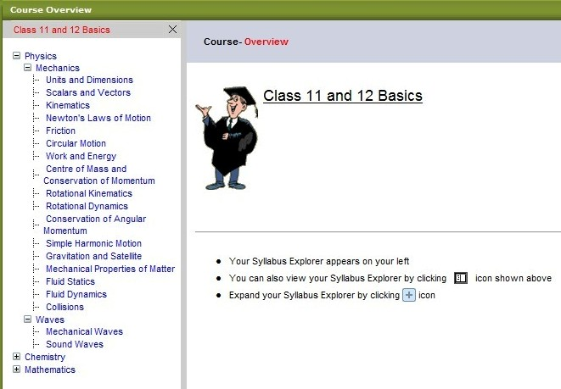
Figure 33: Course Overview
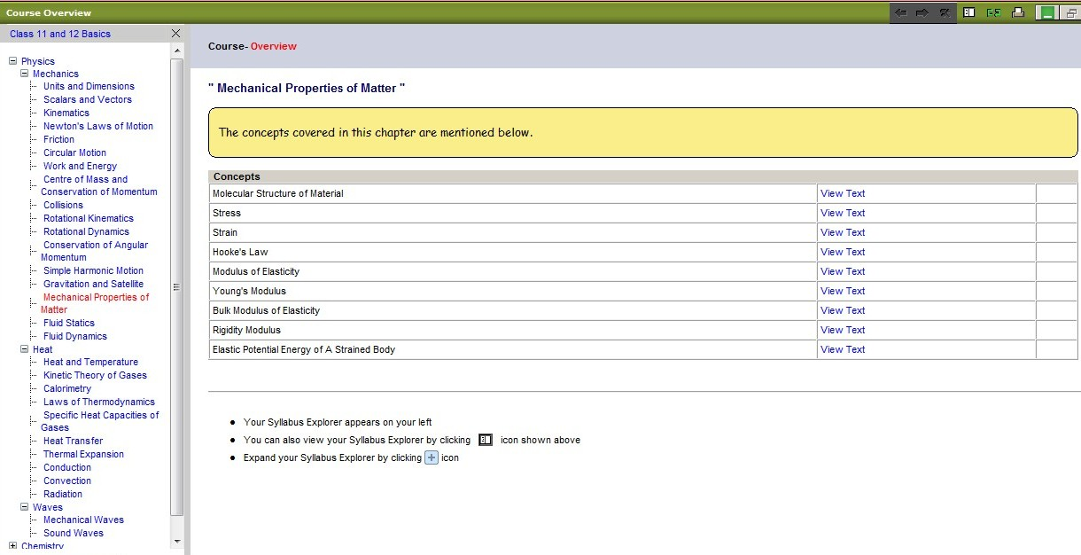
Figure 34: Concept Details

Difficult Question Report
This section allows you to view the most difficult questions and see the number of attempts made to answer the question (see Figures 35 & 36). The statistical data represented in the detailed difficult questions report is based upon the total amount of attempts made to answer the question. The correct answer is shown with a red check mark. The percentages over each answer option show the percentage of student who chose those selections.
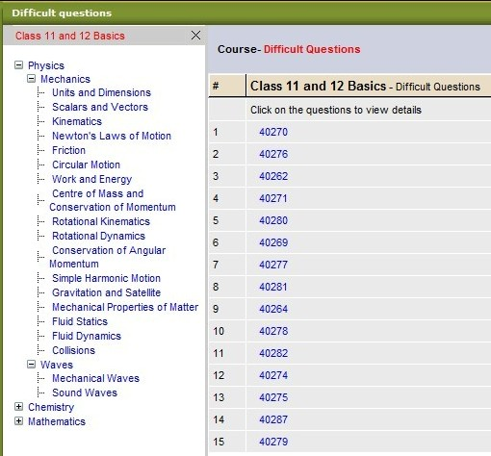
Figure 35: Difficult Questions Report
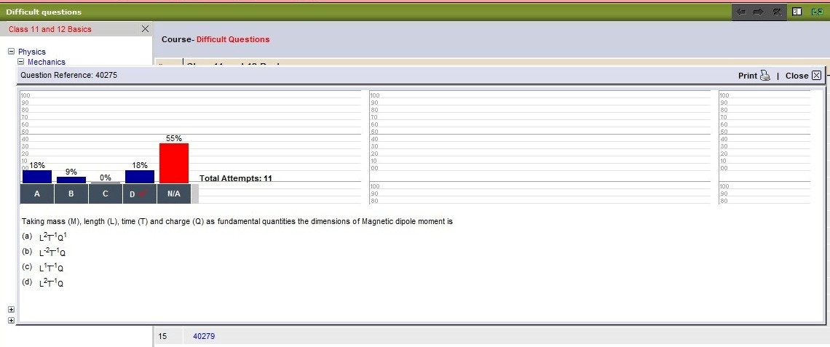
Figure 36: Difficult Questions Report – Detail

Rank Report
The rank report shows the top ten students with the highest rank. The rank information includes the students’ names, email, rank in your group, national rank, and percentile score (see Figure 37). The course syllabus is located to the left of this report. Using the course explorer on the left allows you to go to any section of the course and view the ranking.
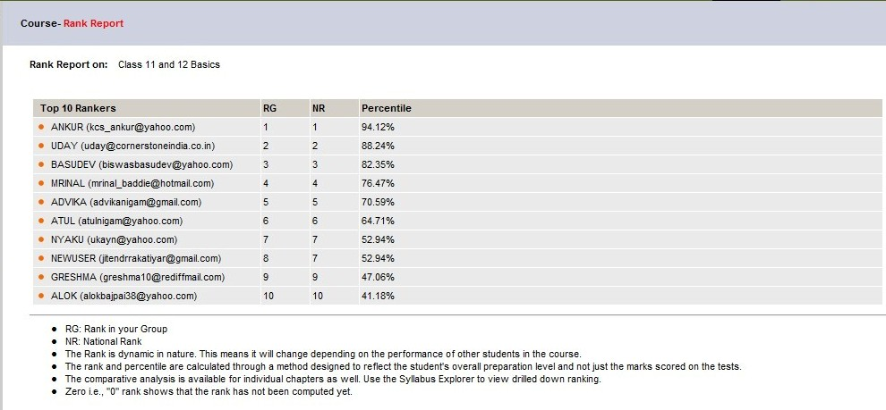
Figure 37: Rank Report

Questions Box
The Questions Box allows students to ask you questions and await your reply (see Figure 38). Inside the questions box you will see the students’ names and the questions asked by each student. While replying to students, you can link the question to other relevant sections of the course. Dynamind will use this to automatically answer similar questions posed in other relevant sections.
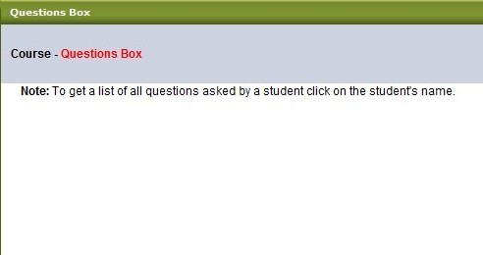
Figure 38: Questions Box

Time Spent
This section allows you to view the time spent by you and the average time students spent on a particular class (see Figure 39). All time is viewed in hours spent. You can view the time spent in any section. To do this, simply expand the course explorer on the left and click on a section (see Figure 40).
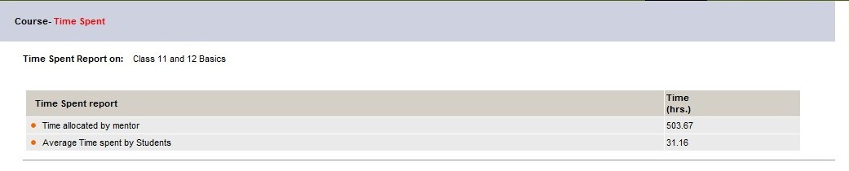
Figure 39: Time Spent

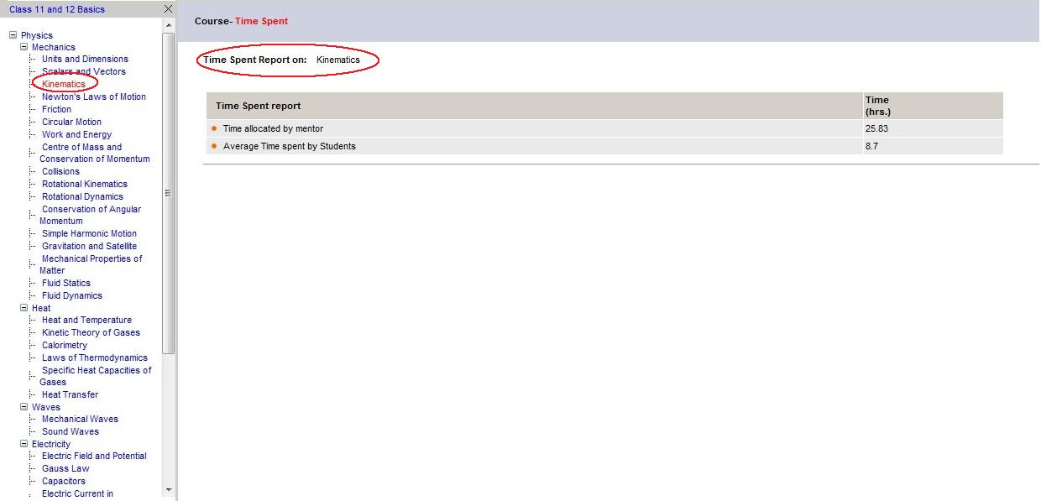
Selected Section
Time Spent on selected section by mentor and by students
Figure 40: Time Spent by Section

Create / Modify Test
As a mentor, you will use this section to create tests for your students. You can also modify or edit tests and delete old tests. To create a test, simply click on the Create New Test button. You will be prompted to enter a test title, description, test number, a start date and time and an end date and time, choose to allow all students to take this test or just selected students, standard or one-on-one test, and either subjective or objective. Once you’ve entered all of this information, click next to continue (see Figures 41-45).You can also import tests from other courses.
Importing tests from other courses consists of six (6) steps.
- Step 1: Click Import Test from other Course on the Create/Modify Test page (see Figure 41).
- Step 2: Select the course of preference from the drop down menu (see Figure 42).
- Step 3: Click the Select Course button (see Figure 43).
- Step 4: Select the test from the drop down menu (see Figure 44).
- Step 5: Click the Import button (see Figure 44).
- Step 6: Return to the main Create/Modify Test page to select the imported test (see Figure 45).
Figure 41: Step 1
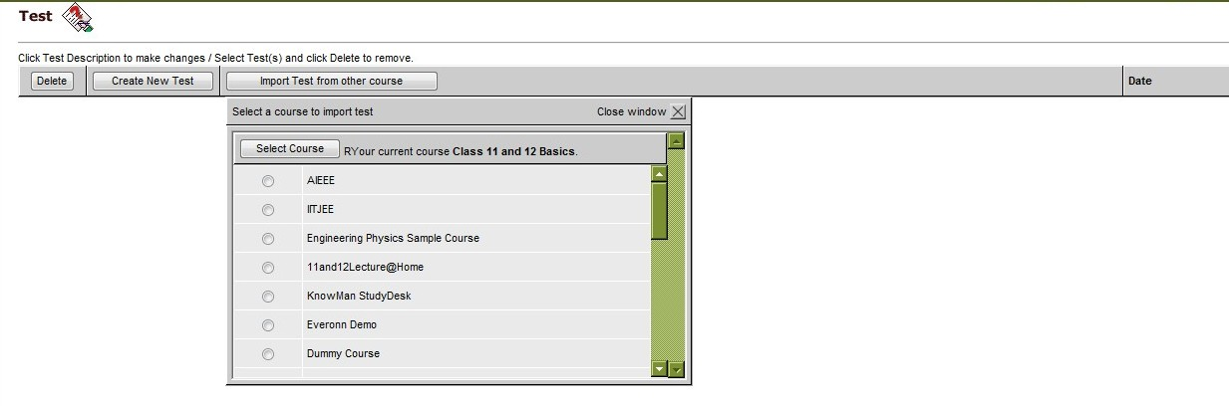
Figure 42: Step 2
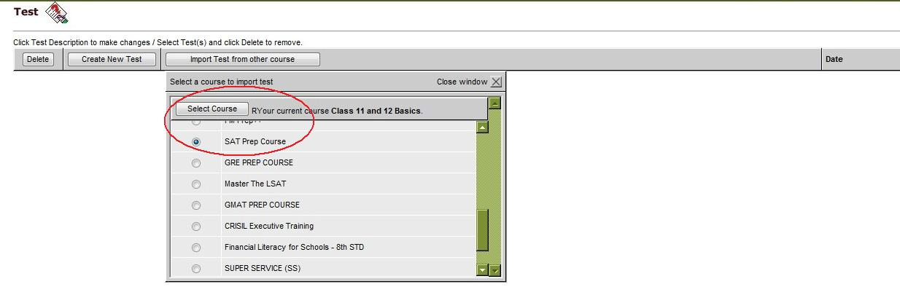
Figure 43: Steps 3
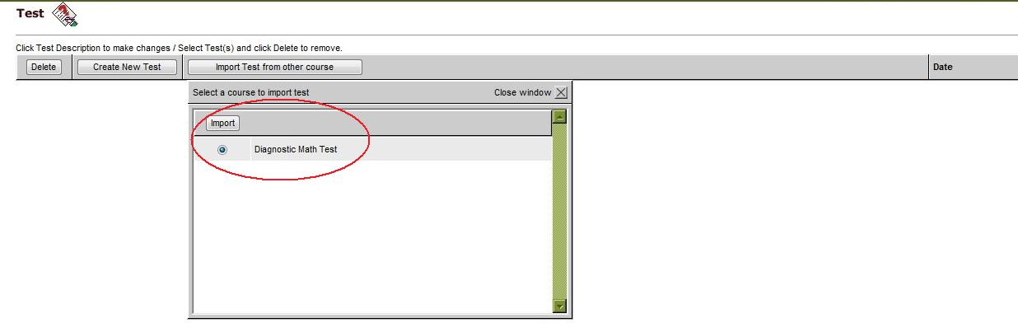
Figure 44: Step 4 & 5
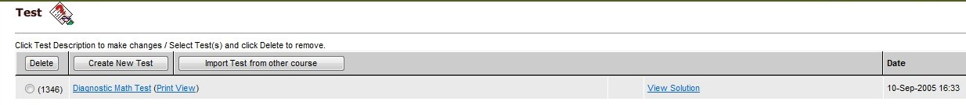
Figure 45: Step 6
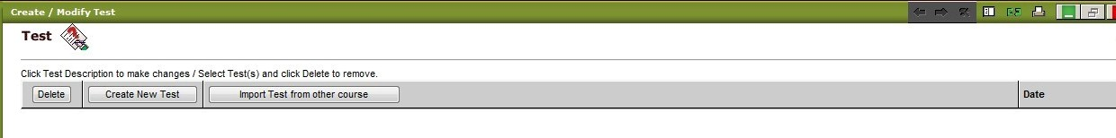
Figure 46: Create / Modify Test

Creating a new test (Figures 47 & 48) is comprised of many steps. Here we will review each step and explain what all of the fields represent.
- Step 1: Click on Create New Test on the toolbar (see Figure 49).
- Step 2: Enter the Test title, number, and instruction or you can browse your computer to upload (see Figure 50).
- Step 3: Enter the Test start date and time and the test end date and time (see Figure 51).
- Step 4: Select the students you wish to view the test, the test mode (standard or one-on-one), and the test type (Objective or Subjective), then click Next (see Figure 52).
- Step 5: Specify the number of test sections, the section title, and instructions or you can browse your computer to upload a test (see Figure 53).
- Step 6: Select the subject, topic, or chapter for the test. Be sure to expand the courses of study by clicking the + sign next to its name. Once you can expanded the courses of study, please make your selections by placing a in the box next to it and then click Submit (see Figure 54).
- Step 7: Enter the number of questions you would like to select and click Save. Choose the number of questions from the left and click the >> to move them to the left. When finished, click Submit & Next (see Figure 55).
- Step 8: After clicking Submit & Next, you will be taken to the section where you can view the questions (see Figure 56). Once your questions are entered correctly, please click Save and then Next to view your test (see Figure 57).
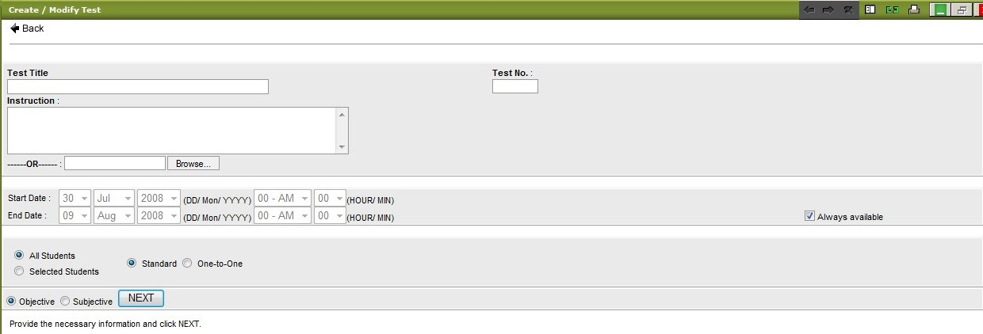
Figure 47: Create New Test - Page 1
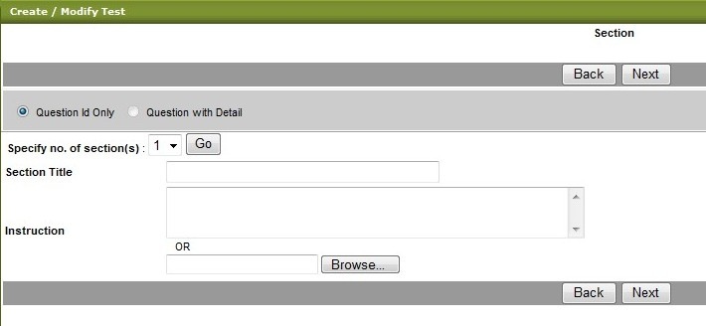
Figure 48: Create New Test - Page 2
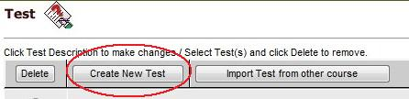
Figure 49: Step 1
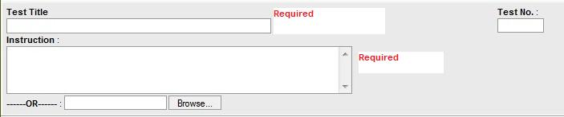
Figure 50: Step 2
Figure 51: Step 3
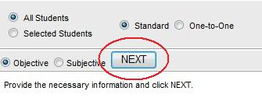
Figure 52: Step 4
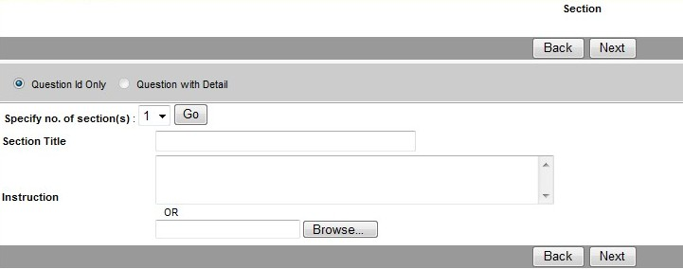
Figure 53: Step 5
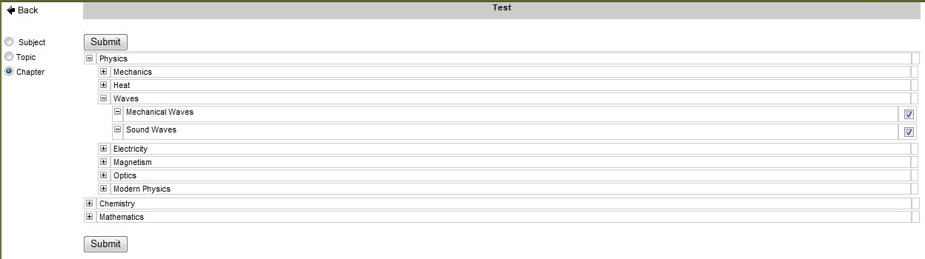
Figure 54: Step 6
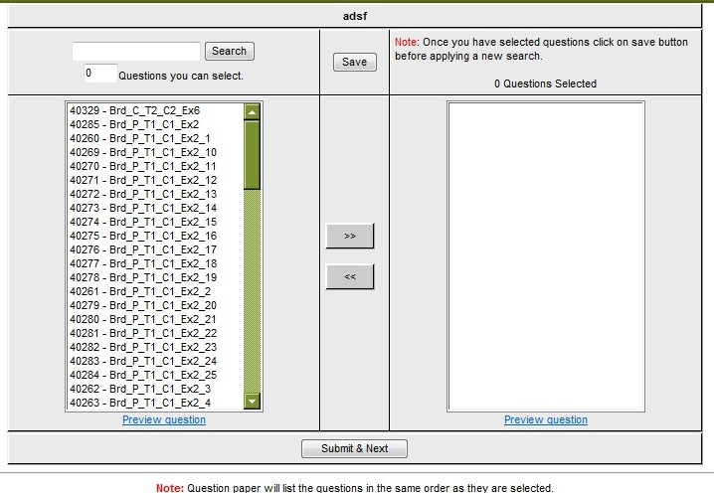
Figure 55: Step 7
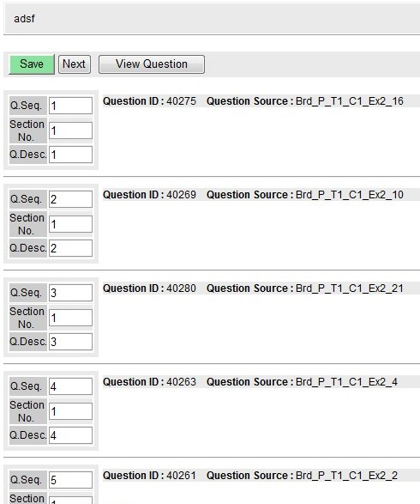
Figure 56: Step 8
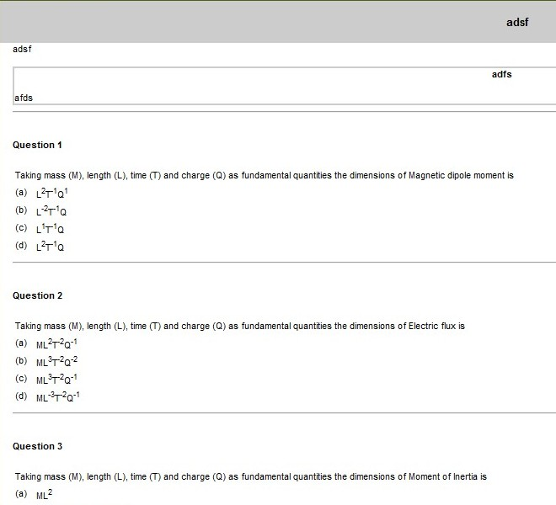
Figure 57: Test Review

Create / Modify Exercise
This section is just like the Create / Modify Test section only it pertains to exercises. You can create, edit, import, or delete exercises for students to complete (see Figure 58). The purpose of these exercises is to help students understand the concepts.
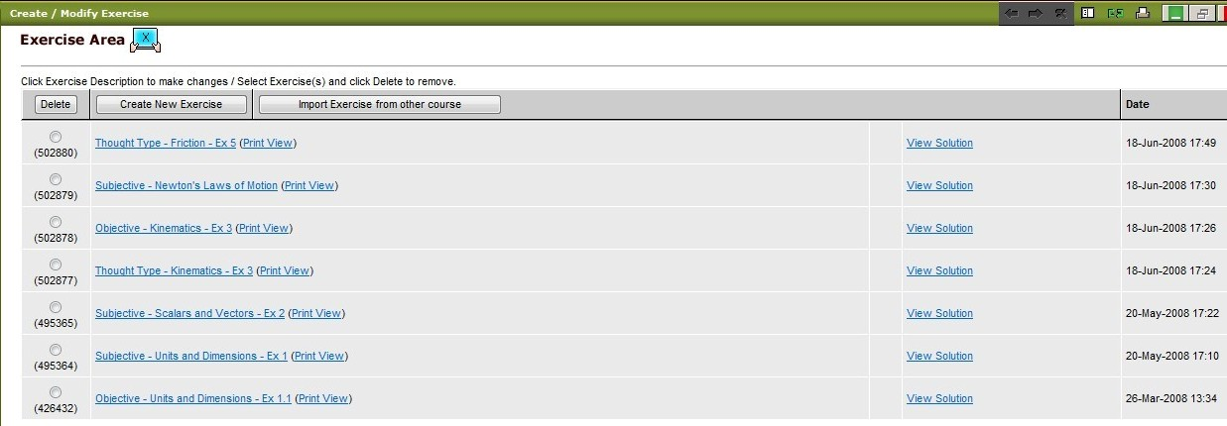
Figure 58: Create / Modify Exercise

Create / Modify Mentor Exercise
This section allows you to create practice tests for your students. It works exactly the same way as create/modify test and create/modify exercise. All of the same information is required and the steps are identical (see Figure 59).
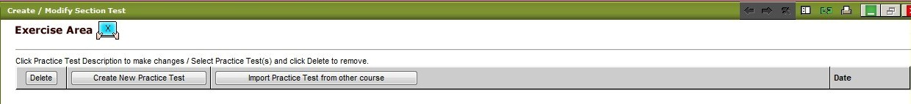
Figure 59: Create/Modify Mentor Exercise

Submit Test
This section allows you to evaluate real-time test papers. This section shows you the test number; test title, received date, evaluation report, summary report, and status of each test (see Figure 60). To submit a test, click on the Evaluate Now link at the far right of the page (see Figure 61). Choose a student from the left side of the screen and review their test (see Figure 62). Once you have reviewed the test, click Submit to submit the test.
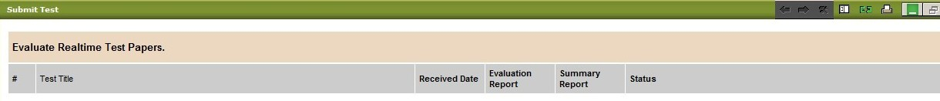
Figure 60: Submit Test
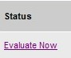
Figure 61: Evaluate Now Link
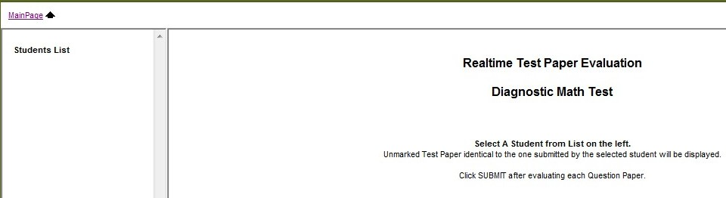
Figure 62: Choose Student

Submit Exercise
This section works just like the Submit Test section. It also provides you with the same types of information, such as exercise number, title, received date, evaluation report, summary report, and status (see Figure 63).
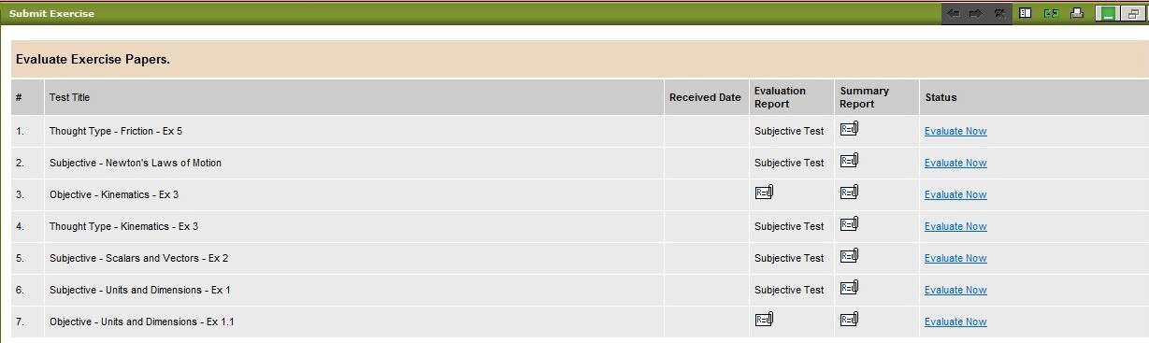
Figure 63: Submit Exercise

Submit Mentor Exercise
This option allows you to evaluate the practice test papers. This option also contains the same information as the submit exercise option (see Figure 64).
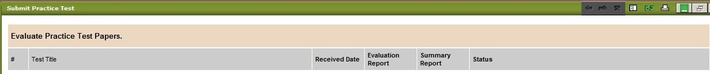
Figure 64: Submit Mentor Exercise

Test Report
This option provides a list of all tests students have attempted. To view test details click on the test title. The test reports show the test description, summary of marks, marks/rank of test center, marks/rank of all students, test statistics reports for the test center and all students and the date (see Figure 65).
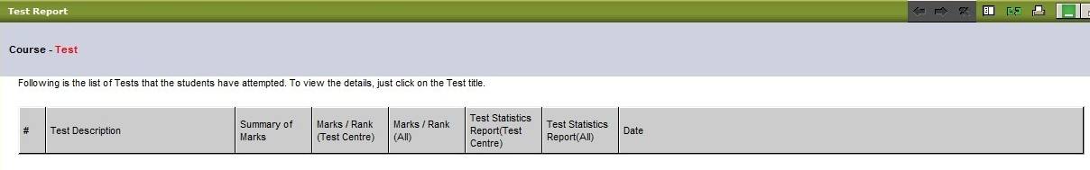
Figure 65: Test Report

Section Test Report
This section allows you to view all section tests that students have attempted. The section test reports page contains all the same information as the test report page, so there’s no need to list them again (see Figure 66).
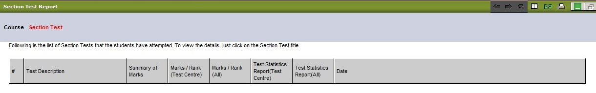
Figure 66: Section Tests Report

Exercise Report
The exercise report page allows you to see all exercises the students have attempted. Again, this page contains all of the same information as the test report and section test report pages (see Figure 67).
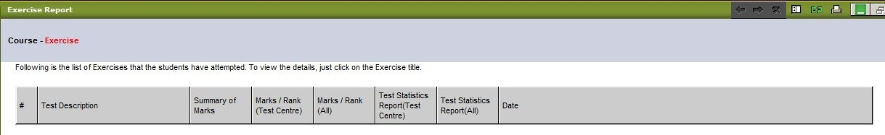
Figure 67: Exercise Report

Student
This section of the WorkDesk allows you to see students’ personal information. This section is broken down into 10 additional options:
Student Personal Details Student Feedback
Rank Report Student Questions
Weak Areas Time Spent
Test Report Section Test Report
Exercise Report Practice Report
Student Attendance

Student Personal Details
This page allows you to search for a student by different parameters. For example, you can search by student name, student username, or student city (see Figure 68).
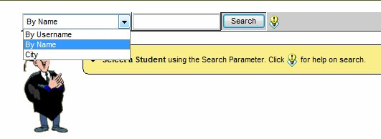
Figure 68: Student Details

Student Feedback
This screen allows you to see all feedback from students (see Figure 69). You can reply to each student’s feedback by clicking on the student’s email address. The subject line is automatically entered as “Your feedback dated [date feedback was submitted].” This screen includes feedback, student, email ID and date. This feedback is course specific, which means that only the students enrolled in specific classes will be permitted to leave feedback here.
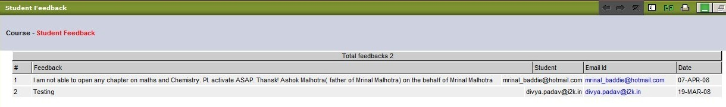
Figure 69: Student Feedback

Rank Report
This page allows you to search for a student using the same parameters as the student personal details search. You can also view student rank by clicking on a topic on the left of the screen. Once you’ve located the correct student, you can view his/her rank details (see Figure 70).
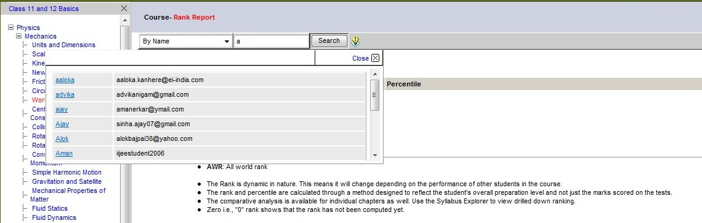
Figure 70: Student Rank Report

Student Questions
To see if any students have questions, you first search for a student, using the same parameters as before. Once you’ve located the appropriate student, all student questions, if any, will appear in the space below the student’s name (see Figure 71). To answer these questions, simply click on the student’s email address and type your response.
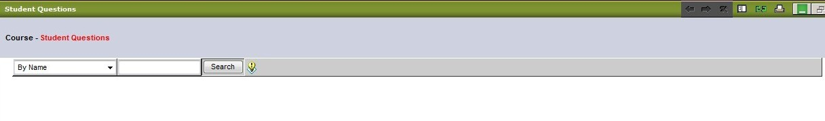
Figure 71: Student Questions

Weak Areas
To determine the weak areas of a student, you must first search for that student. Again, all search parameters are the same; search by name, username, or city. Once you’ve located the proper student, use the Course Explorer on the left to determine his/her weak areas. You can view the weak areas by topic, subject or chapter (see Figure 72). Once you have located the student you searched for, his/her weak areas will appear on the screen (see Figure 73).
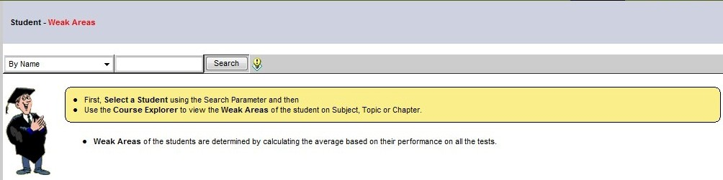
Figure 72: Weak Areas
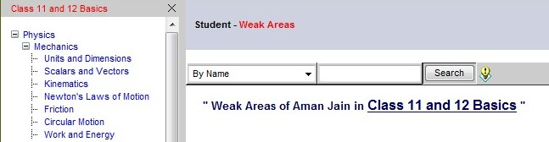
Figure 23: Weak Areas

Time Spent
This section allows you to see how much time each student has spent in class. The time spent is also seen at the course, subject, topic, and chapter level. Please remember that all time spent is calculated in hours (see Figure 74).
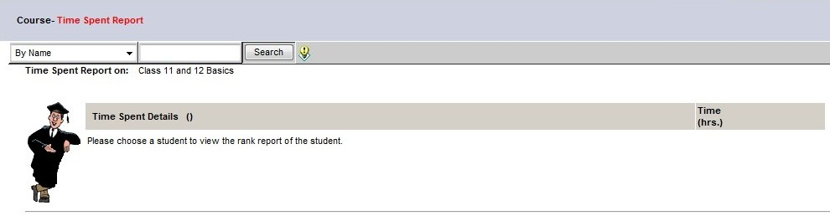
Figure 74: Time Spent

Test Report
The test report page allows you to see all tests that have been submitted by the student. These tests are ones that you create by using the Administrator options previously discussed. To find the test report for a student, please search for that student using the search parameters. Once the student is located, his/her information will appear under the search box.
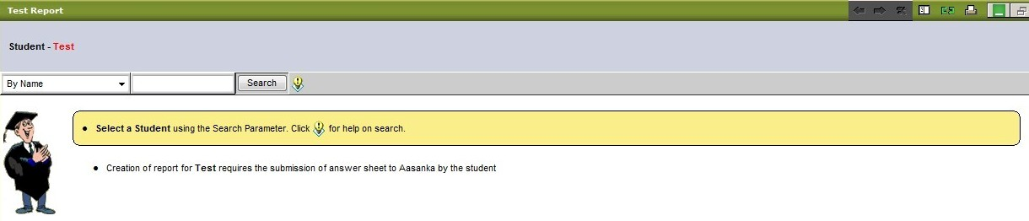
Figure 75: Test Report

Section Test Report
This section is very similar to the test report section. To create a section test report for a student, the student must have submitted his/her section test online. To find this information, you must first search for the student using the given parameters (see Figure 76).
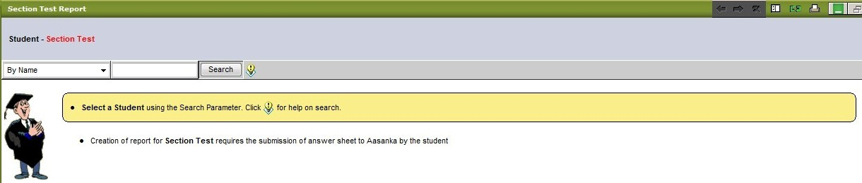
Figure 76: Section Test Report

Exercise Report
This page allows you to create student specific reports based on the submitted exercises. If the student has not submitted his/her exercises, the report cannot be generated. To create a student specific report, you must first search for the student. Once the student has been located, the search results will be displayed under the search box (see Figure 78).
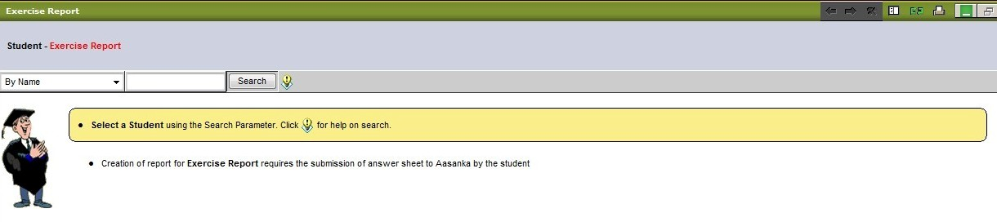
Figure 78: Exercise Report

Practice Report
This feature is just like all the other student report features. You must first search for the student. As with the previous student reports, this report cannot be generated unless the student has submitted it online. Once you have found your student, the search results will appear below the search box (see Figure 79).
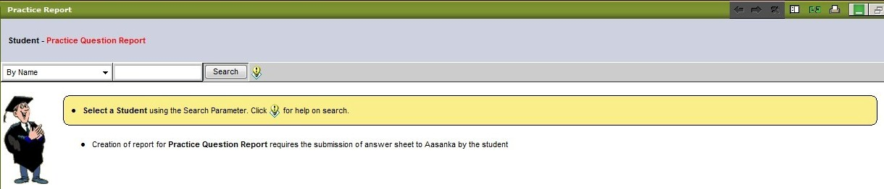
Figure 79: Practice Report
Student Attendance
The student attendance section allows you to view the attendance of each student. Figure 80 shows the search parameters for finding the students whose attendance you wish to view.
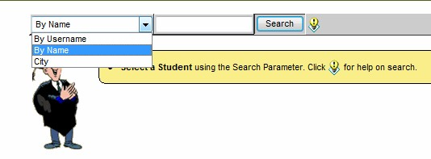
Figure 80: Student Attendance
Once you have located your student, select the dates you wish to review from the drop down menu at the top of the screen (see Figure 81).
Figure 81: Select Attendance Dates
After selecting the dates you wish to review, click Submit and the requested results will appear on the screen (see Figure 82).
Figure 82: Student Visits

Congratulations!
You have now successfully mastered the
Mentor’s WorkDesk. You are now ready
to begin assisting students in their quest
for knowledge. Good luck!

